Serial Robot Kinematics

Alex Thompson (10004785)

Table of Contents

1. Introduction 4

2. Kinematics 4

2.1 Robot Arm Specifications 4

2.2 DH table and diagram 6

2.3 Forward Kinematics 7

2.3.1 Transformation Matrices 7

2.3.2 Verification and Testing 8

2.4 Workspace 10

2.4.1 Matlab Approach 10

2.4.2 Geometric Approach 11

2.5 Inverse Kinematics 13

2.5.1 Mathematics 13

2.5.2 Testing 15

2.6 Task 18

2.6.1 Limit Testing 18

2.6.2 Task Plan 18

2.6.3 IK and Simulation Positions 19

2.7 Kinematics Summary 22

3. Intelligence 23

4. Expansion 26

GUI Arm Simulation 26

Machine Vision System 26

5. Appendix 27

1.0 Matlab Code 27

1.1 Solving T1E Using Matlab: 27

1.2 Testing the Forward Kinematics 27

1.3 Calculating the workspace 28

1.4 Simulating the Arm 30

1.5 Testing Inverse Kinematics 31

1.6 GUI interface 31

1.7 runfile.py testing 31

2.0 Math 34

2.1 Trigonometric Identities 34

2.2 Forward kinematics 34

6. References 36

# Introduction

This report focuses on a serial robot arm called the lynx motion. The aim of the report is to explore the kinematics of this arm, both in methods of derivation and in application. The report is divided into three main parts:

1. The kinematics of the arm including deriving the forward kinematics (FK), inverse kinematics (IK), workspace, simulated testing of the kinematics solutions, and real world testing.
2. Artificial Intelligence techniques including deriving an ANFIS representation of the IK of the arm, simulated testing of the IK generated in this manner, and real world testing.
3. An expansion on the required kinematics including a GUI interface for control of a simulated lynx motion arm.

# Kinematics

## 2.1 Robot Arm Specifications

The arm used in this report was #10.

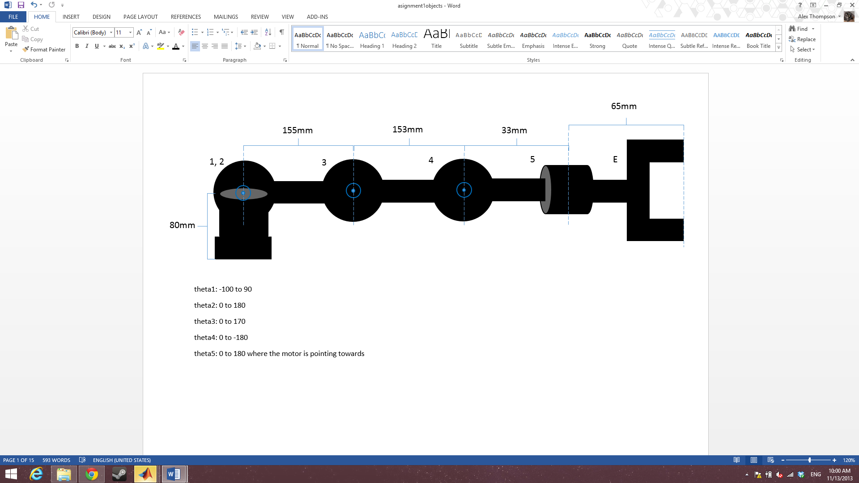

Figure 1

|  |  |
| --- | --- |
| **Links Dimensions** | |
| **part** | **length** |
| base to shoulder | 85mm |
| shoulder to elbow | 93mm |
| elbow to wrist | 108mm |
| wrist to rotator | 33mm |
| rotator to end effector | 37mm |

|  |  |
| --- | --- |
| **Joint Limitations** | |
| joint | **rotation limitations** |
| $$θ_{1}$$ | -105 to 100 |
| $$θ_{2}$$ | 0 to 140 |
| $$θ_{3}$$ | 0 to -160 |
| $$θ_{4}$$ | -110 to 70 *needs to be fixed |
| $$θ_{5}$$ | -100 to 100 |

|  |  |
| --- | --- |
| **Servo Specifications** | |
| pwm min | 500 µs |
| pwm max | 2500 µs |
| channels | 0 - 6 |
| max move time | 65535 ms |

To convert from degrees to motor PWM:

$$\frac{range motor}{range in degrees}=\frac{2500-500}{180}$$

## 2.2 DH table and diagram

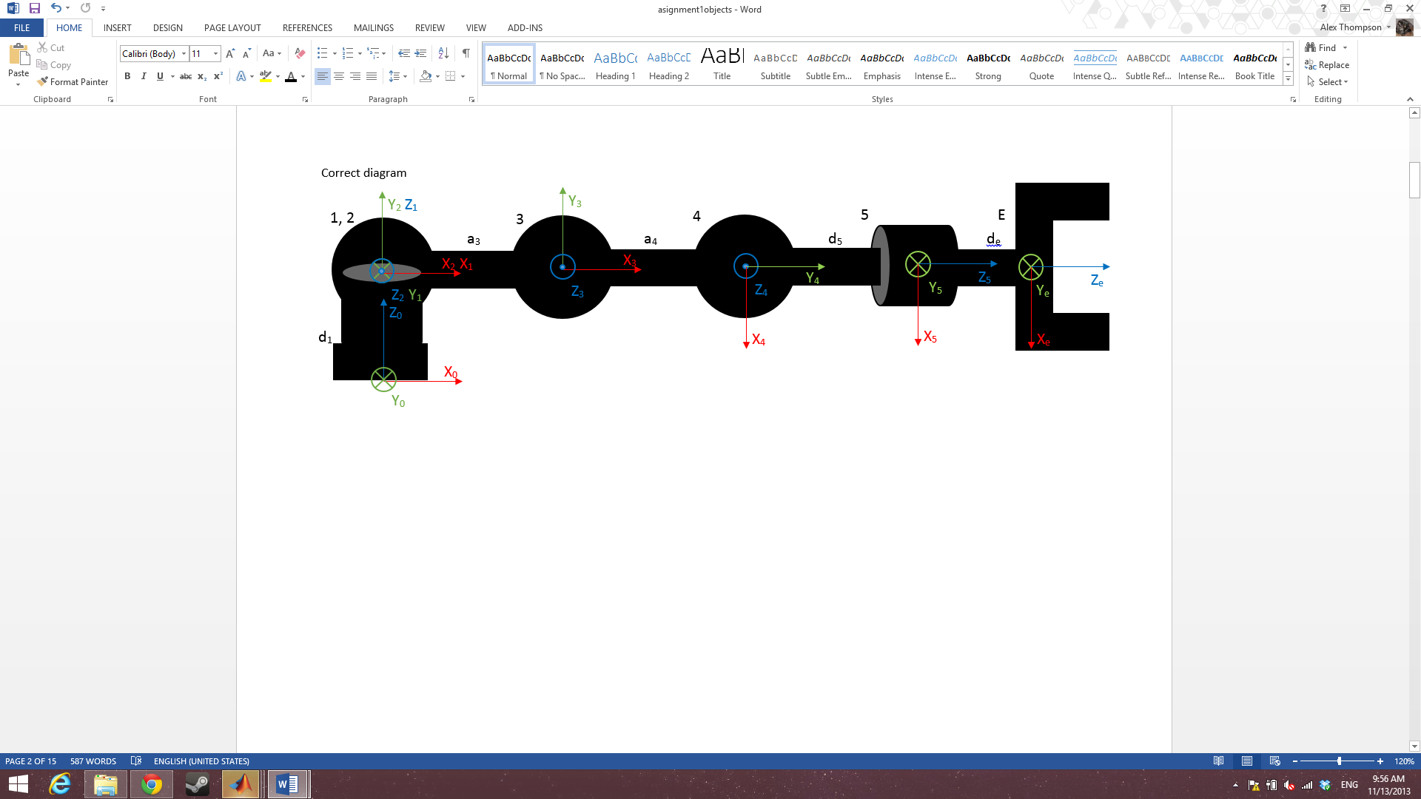

Figure 2

To choose the orientation of each frame I aligned z along the axis of rotation for each joint.

|  |  |  |  |  |
| --- | --- | --- | --- | --- |
| i | αi-1 | ai-1 | di-1 |  |
| 1 | 0 | 0 | d1 |  |
| 2 | 90 | 0 | 0 |  |
| 3 | 0 | a3 | 0 |  |
| 4 | 0 | a4 | 0 |  |
| 5 | -90 | 0 | d5 |  |
| E | 0 | 0 | dE |  |

The DH table was derived using the proximal methodology. Each element of it is found using the following:

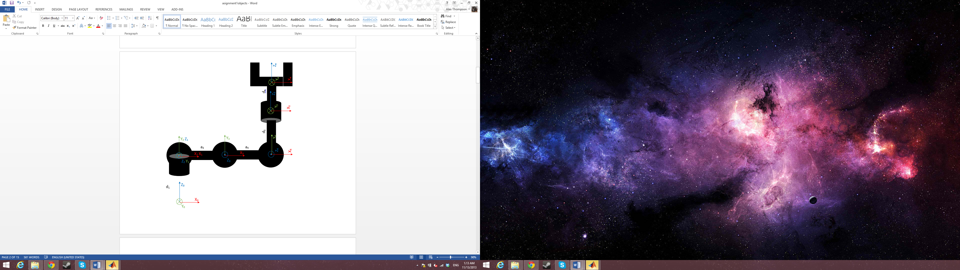alpha is the rotation about the x axis when comparing i-1 to i.

a is the distance traveled along the x axis from i-1 to i.

d is the distance traveled along the z axis from i-1 to i.

$θ$ is the rotation about the z axis when comparing i-1 to i.

An exception to the above that came into play is that when

When all theta=0 the arms orientation is:

Figure 3

## 2.3 Forward Kinematics

The forward kinematics of a robot arm allow for the location of an end effector to be determined from the angles of its joints. It can be derived using a proximal or distal approach using the DH table.

### 2.3.1 Transformation Matrices

Using the generalized equation for proximal.

$${}_{i}^{i-1}T=\left[\begin{matrix}\cos{θ_{i}} & -\sin{θ_{i}} & 0 & a_{i-1} \\ \sin{θ_{i}}\cos{α_{i-1}} & \cos{θ_{i}}\cos{α_{i-1}} & -\sin{α_{i-1}} & -\sin{α_{i-1}}d_{i} \\ \sin{θ_{i}}\sin{α_{i-1}} & \cos{θ_{i}}\sin{α_{i-1}} & \cos{α_{i-1}} & \cos{α_{i-1}}d_{i} \\ 0 & 0 & 0 & 1\end{matrix}\right]$$

$${}_{1}^{0}T=\left[\begin{matrix}\cos{θ_{1}} & -\sin{θ_{1}} & 0 & 0 \\ \sin{θ_{1}}\cos{(0)} & \cos{θ_{1}}\cos{(0)} & -\sin{(0)} & -\sin{(0)}d_{1} \\ \sin{θ_{1}}\sin{(0)} & \cos{θ_{1}}\sin{(0)} & \cos{(0)} & \cos{(0)}d_{1} \\ 0 & 0 & 0 & 1\end{matrix}\right]=\left[\begin{matrix}\cos{θ_{1}} & -\sin{θ_{1}} & 0 & 0 \\ \sin{θ_{1}} & \cos{θ_{1}} & 0 & 0 \\ 0 & 0 & 1 & d_{1} \\ 0 & 0 & 0 & 1\end{matrix}\right]$$

$${}_{2}^{1}T=\left[\begin{matrix}\cos{θ_{2}} & -\sin{θ_{2}} & 0 & 0 \\ \sin{θ_{2}}\cos{(90)} & \cos{θ_{2}}\cos{(90)} & -\sin{(90)} & -\sin\left(90\right)(0) \\ \sin{θ_{2}}\sin{(90)} & \cos{θ_{2}}\sin{(90)} & \cos{(90)} & \cos{(90)}(0) \\ 0 & 0 & 0 & 1\end{matrix}\right]=\left[\begin{matrix}\cos{θ_{2}} & -\sin{θ_{2}} & 0 & 0 \\ 0 & 0 & -1 & 0 \\ \sin{θ_{2}} & \cos{θ_{2}} & 0 & 0 \\ 0 & 0 & 0 & 1\end{matrix}\right]$$

$${}_{3}^{2}T=\left[\begin{matrix}\cos{θ_{3}} & -\sin{θ_{3}} & 0 & a_{3} \\ \sin{θ_{3}}\cos{(0)} & \cos{θ_{3}}\cos{(0)} & -\sin{(0)} & -\sin{(0)}(0) \\ \sin{θ_{3}}\sin{(0)} & \cos{θ_{3}}\sin{(0)} & \cos{(0)} & \cos{(0)}(0) \\ 0 & 0 & 0 & 1\end{matrix}\right]=\left[\begin{matrix}\cos{θ_{3}} & -\sin{θ_{3}} & 0 & a_{3} \\ \sin{θ_{3}} & \cos{θ_{3}} & 0 & 0 \\ 0 & 0 & 1 & 0 \\ 0 & 0 & 0 & 1\end{matrix}\right]$$

$${}_{4}^{3}T=\left[\begin{matrix}\cos{θ_{4}} & -\sin{θ_{4}} & 0 & a_{4} \\ \sin{θ_{4}}\cos{(0)} & \cos{θ_{4}}\cos{(0)} & -\sin{(0)} & -\sin{(0)}(0) \\ \sin{θ_{4}}\sin{(0)} & \cos{θ_{4}}\sin{(0)} & \cos{(0)} & \cos{(0)}(0) \\ 0 & 0 & 0 & 1\end{matrix}\right]=\left[\begin{matrix}\cos{θ_{4}} & -\sin{θ_{4}} & 0 & a_{4} \\ \sin{θ_{4}} & \cos{θ_{4}} & 0 & 0 \\ 0 & 0 & 1 & 0 \\ 0 & 0 & 0 & 1\end{matrix}\right]$$

$${}_{5}^{4}T=\left[\begin{matrix}\cos{θ_{5}} & -\sin{θ_{5}} & 0 & 0 \\ \sin{θ_{5}}\cos{(-90)} & \cos{θ_{5}}\cos{(-90)} & -\sin{(-90)} & -\sin{(-90)}d_{5} \\ \sin{θ_{5}}\sin{(-90)} & \cos{θ_{5}}\sin{(-90)} & \cos{(-90)} & \cos{(-90)}d_{5} \\ 0 & 0 & 0 & 1\end{matrix}\right]=\left[\begin{matrix}\cos{θ_{5}} & -\sin{θ_{5}} & 0 & 0 \\ 0 & 0 & 1 & d_{5} \\ -sin{θ_{5}} & -cos{θ_{5}} & 0 & 0 \\ 0 & 0 & 0 & 1\end{matrix}\right]$$

$${}_{E}^{5}T=\left[\begin{matrix}\cos{θ_{E}} & -\sin{θ_{E}} & 0 & 0 \\ \sin{θ_{E}}\cos{(0)} & \cos{θ_{E}}\cos{(0)} & -\sin{(0)} & -\sin{(0)}d_{E} \\ \sin{θ_{E}}\sin{(0)} & \cos{θ_{E}}\sin{(0)} & \cos{(0)} & \cos{(0)}d_{E} \\ 0 & 0 & 0 & 1\end{matrix}\right]=\left[\begin{matrix}1 & 0 & 0 & 0 \\ 0 & 1 & 0 & 0 \\ 0 & 0 & 1 & d_{E} \\ 0 & 0 & 0 & 1\end{matrix}\right]$$

$${}_{1}^{0}T{}_{2}^{1}T{}_{3}^{2}T{}_{4}^{3}T{}_{5}^{4}T=\left[\begin{matrix}r_{11} & r_{12} & r_{13} & p_{x} \\ r_{21} & r_{22} & r_{23} & p_{y} \\ r_{31} & r_{32} & r_{33} & p_{z} \\ 0 & 0 & 0 & 1\end{matrix}\right]$$

See appendix 2.2 for the values of the above matrix

Using:

$\sin\left(θ_{i}\right)=S_{i}$

$$\cos{(θ_{i})}=C_{i}$$

$$\sin\left(θ_{i}+θ_{j}\right)=S_{ij}$$

$$\cos{(θ_{i}+θ_{j})}=C_{ij}$$

$$\left[\begin{matrix}r_{11} & r_{12} & r_{13} \\ r_{21} & r_{22} & r_{23} \\ r_{31} & r_{32} & r_{33}\end{matrix}\right]=\left[\begin{matrix}C_{234}C_{1}C_{5}-S_{1}S_{1} & -C_{5}S_{1}-C_{234}C_{1} & -S_{234}C_{1} \\ C_{1}S_{5}+C_{234}C_{5}S_{1} & C_{1}C_{5}-C_{234}S_{1}S_{5} & -S_{234}S_{1} \\ S_{234}C_{5} & -S_{234}S_{5} & C_{234}\end{matrix}\right]$$

$$\left[\begin{matrix}p_{x} \\ p_{y} \\ p_{z}\end{matrix}\right]=\left[\begin{matrix}C_{1}\left(a_{4}C_{23}+a_{3}C_{2}{-d}_{5}S_{234}{-d}_{E}S_{234}\right) \\ S_{1}\left(a_{4}C_{23}+a_{3}C_{2}{-d}_{5}S_{234}{-d}_{E}S_{234}\right) \\ d_{1}+a_{4}S_{23}+a_{3}S_{2}+d_{5}C_{234}+d_{E}C_{234}\end{matrix}\right]=\left[\begin{matrix}C_{1}\left(a_{4}C_{23}+a_{3}C_{2}-\left(d_{5}+d_{E}\right)S_{234}\right) \\ S_{1}\left(a_{4}C_{23}+a_{3}C_{2}-\left(d_{5}+d_{E}\right)S_{234}\right) \\ d_{1}+a_{4}S_{23}+a_{3}S_{2}+\left(d_{5}+d_{E}\right)C_{234}\end{matrix}\right]$$

### 2.3.2 Verification and Testing

Matlab was used to verify the mathematical accuracy of the above matrices (see appendix 1.1).

Further testing was done in matlab to check the sensibility of values returned from the forward kinematics (see appendix 1.2).

Once proved accurate and verified, the forward kinematics were further tested by simulating the arm in 3 positions (see appendix 1.4 for Matlab code).

Test 1

theta1=0; theta2=0; theta3=0; theta4=0; theta5=0;

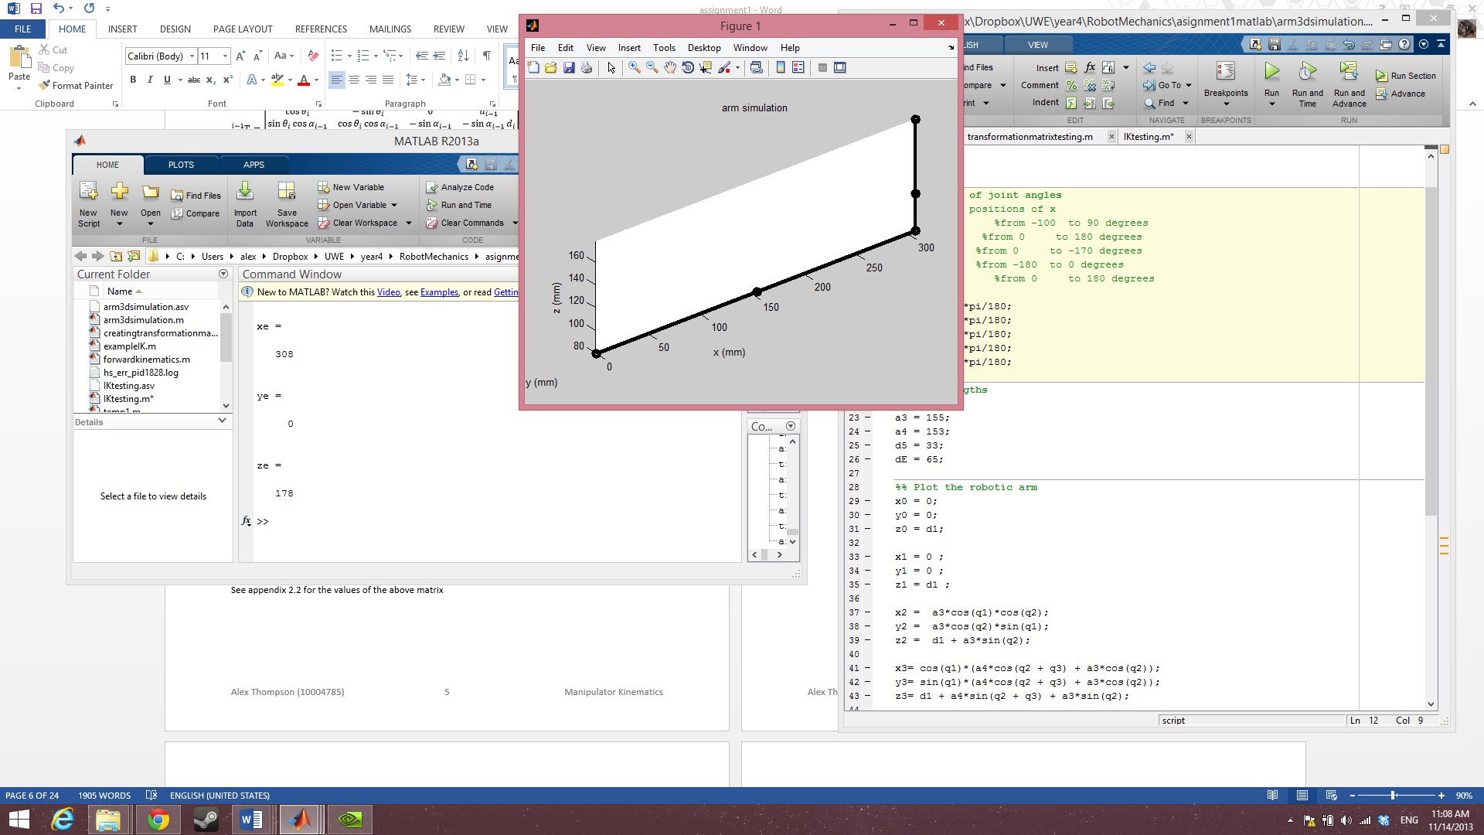 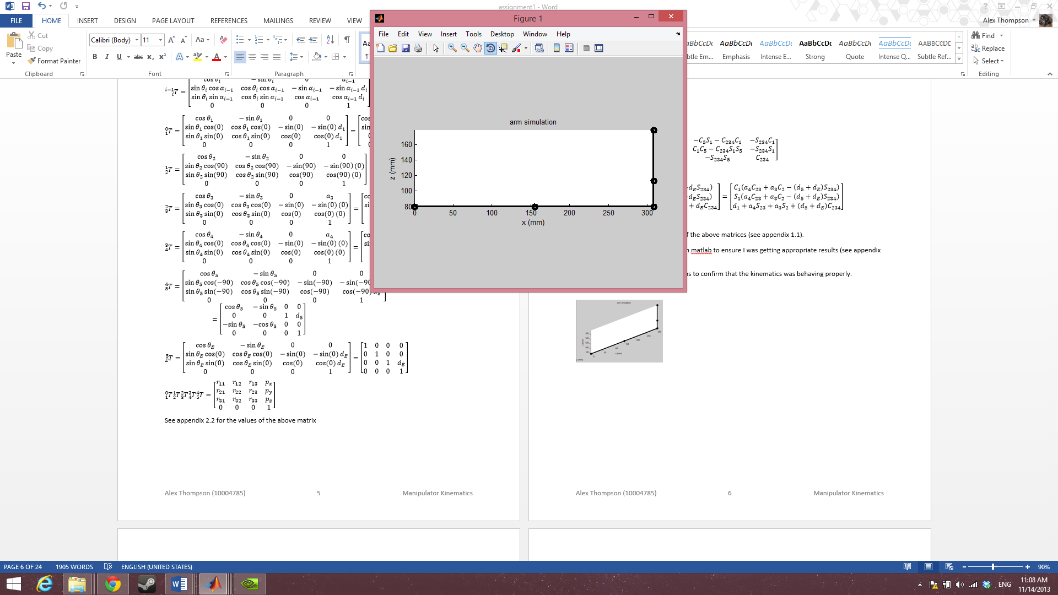

T1E =

1 0 0 308

0 1 0 0

0 0 1 178

0 0 0 1

Figure 5

Figure 4

Test 2

theta1=0; theta2=90; theta3=-90; theta4=-90; theta5=50;

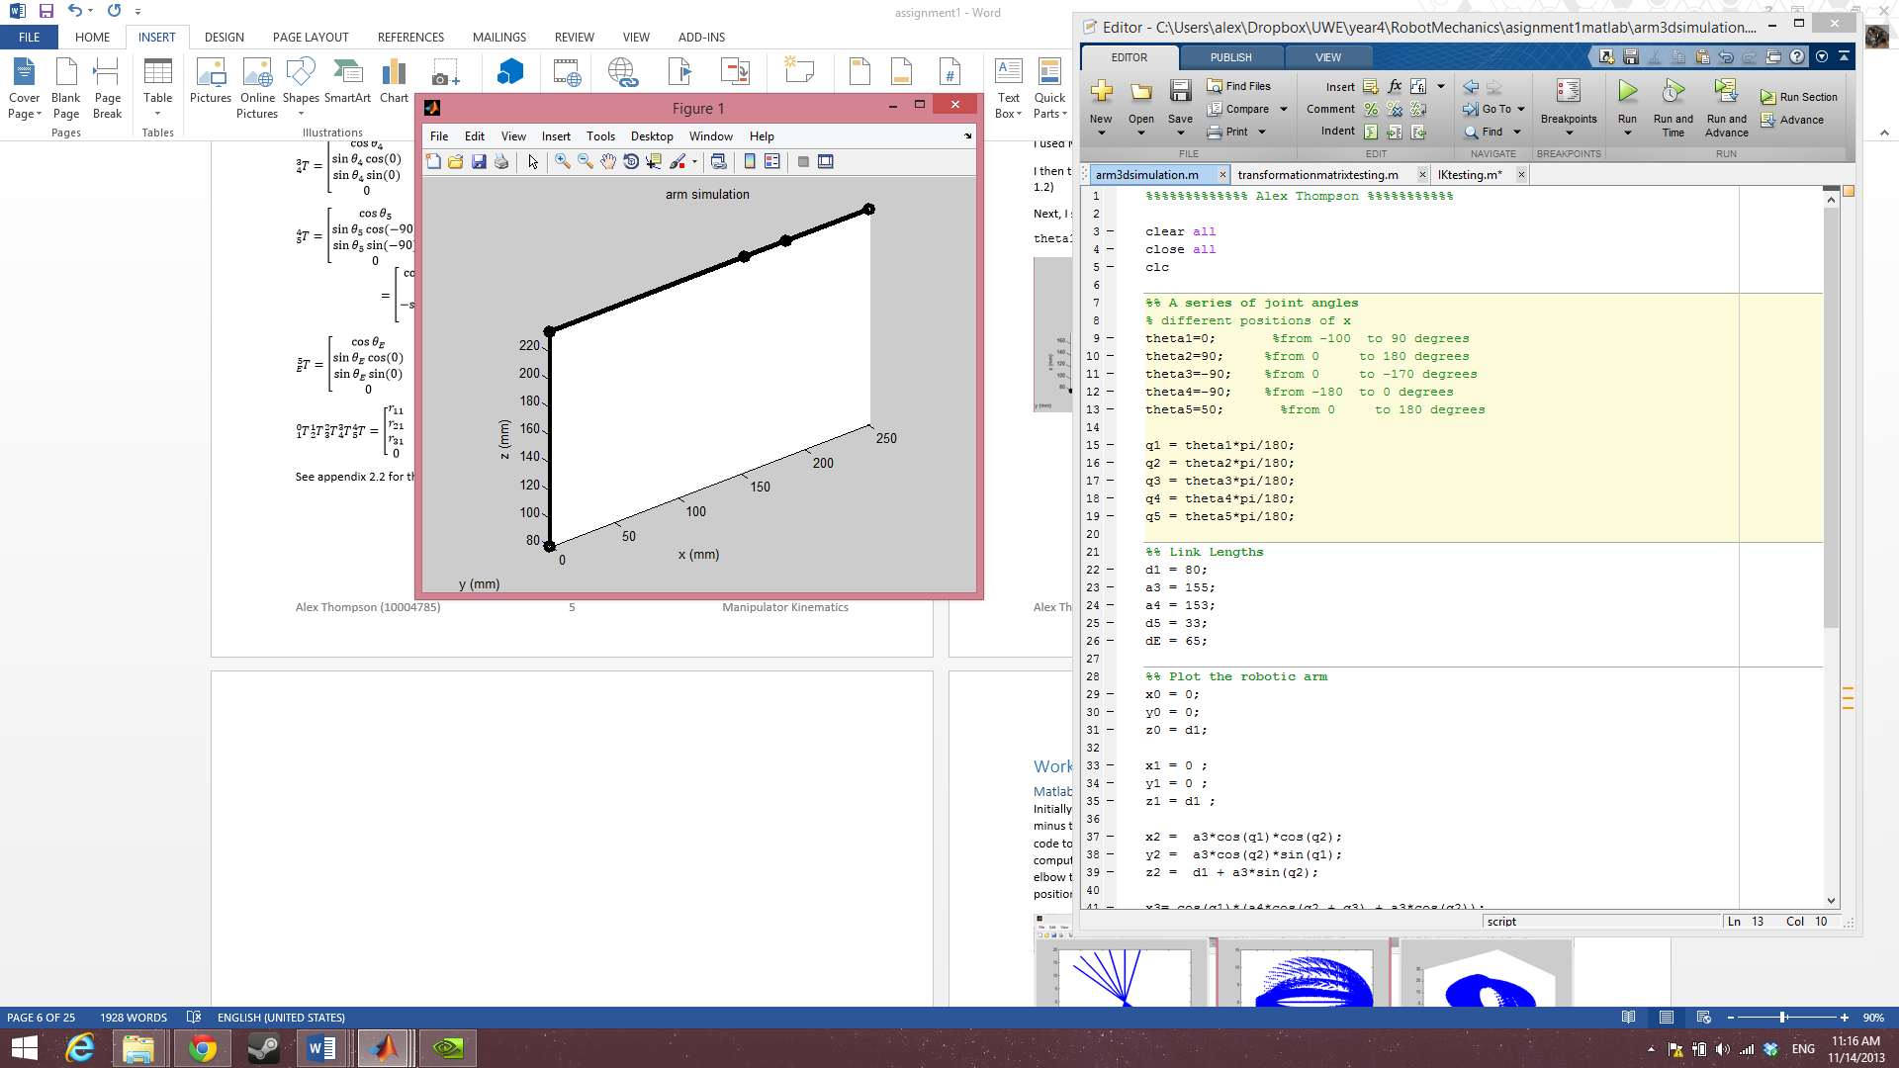 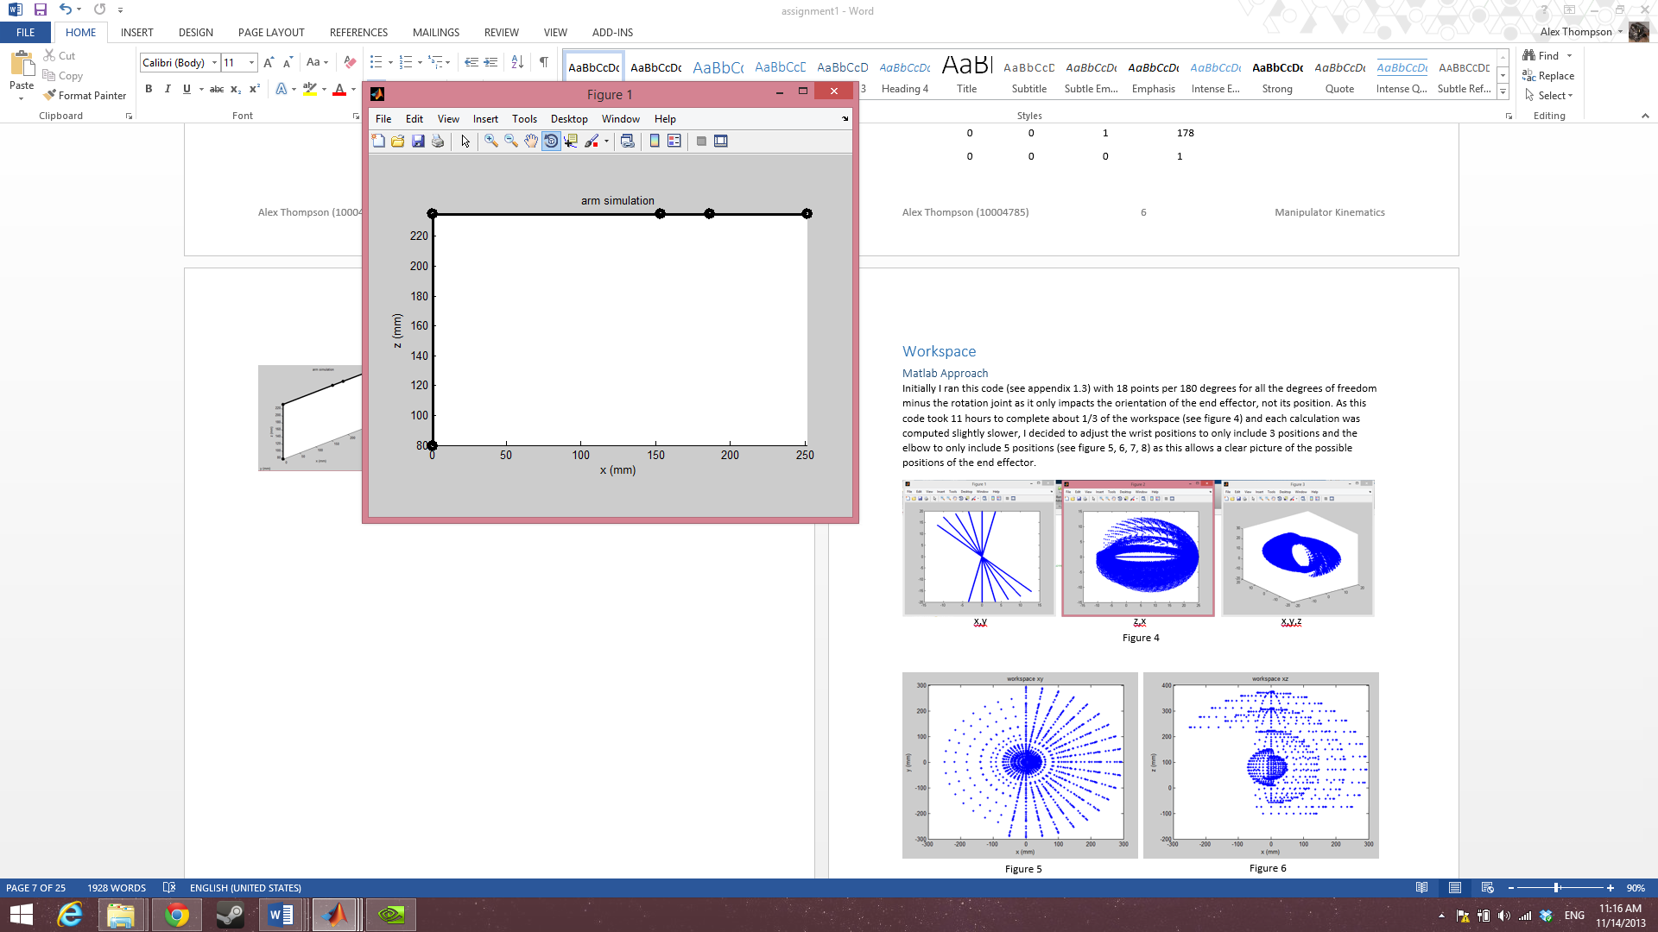

Figure 7

Figure 6

T1E =

0.0000 -0.0000 1.0000 251.0000

0.7660 0.6428 0 0

-0.6428 0.7660 0.0000 235.0000

0 0 0 1.0000

Test 3

theta1=-80; theta2=90; theta3=-90; theta4=-180; theta5=50;

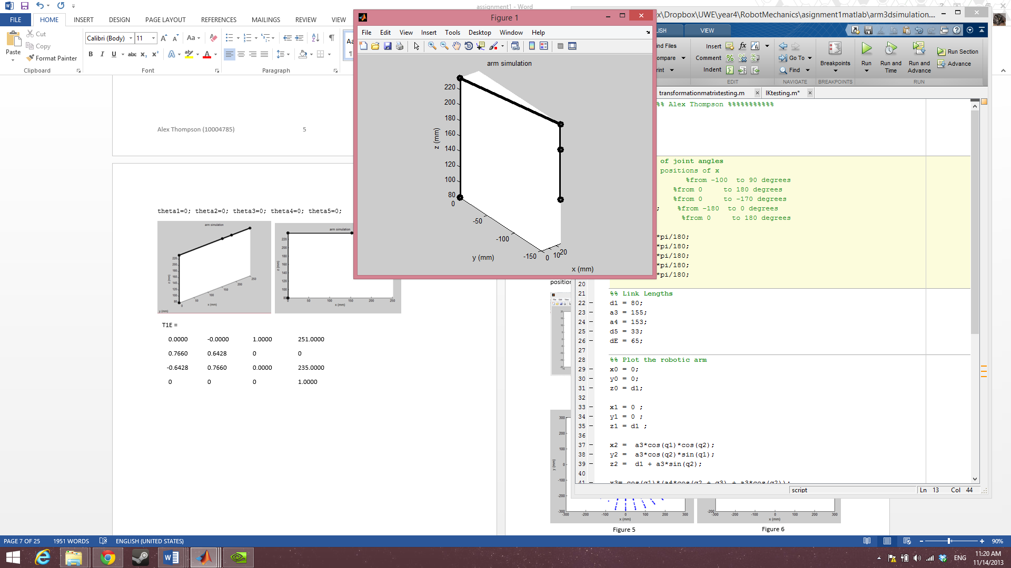 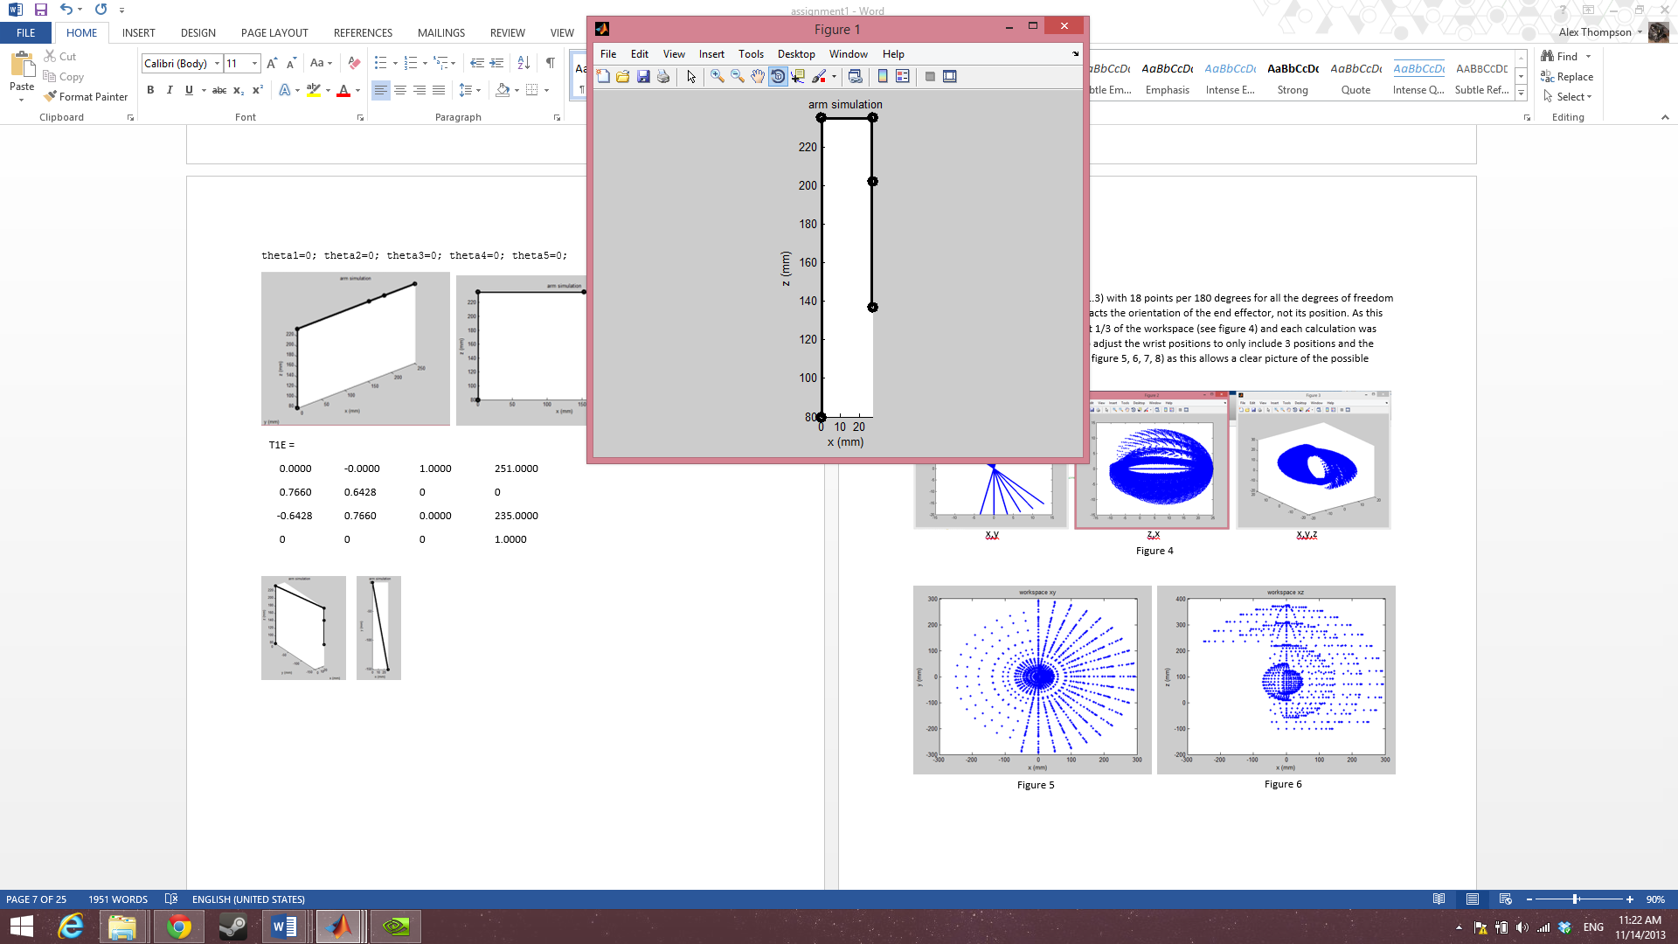 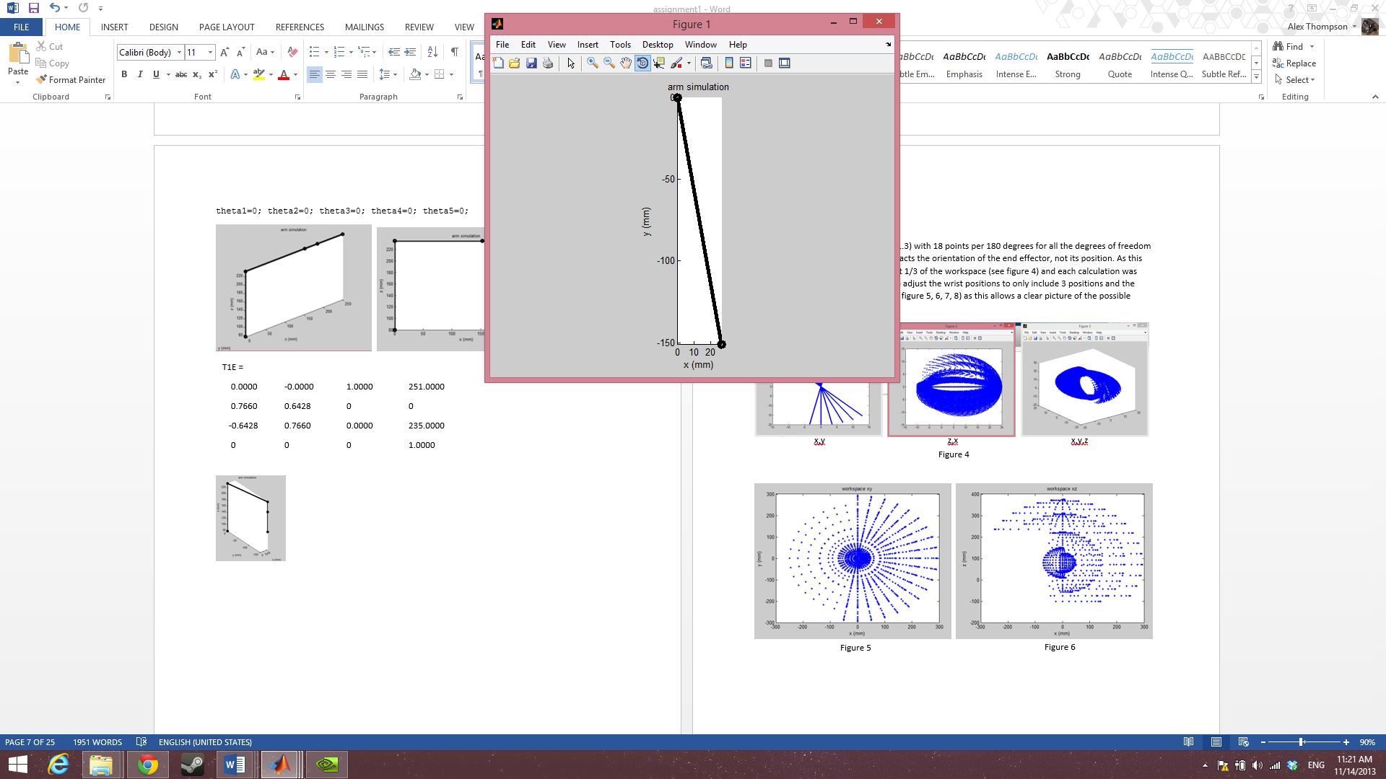

Figure 10

Figure 9

Figure 8

Figure 3

T1E =

0.6428 0.7660 0.0000 26.5682

0.7660 -0.6428 -0.0000 -150.6756

-0.0000 0.0000 -1.0000 137.0000

0 0 0 1.0000

## 2.4 Workspace

The workspace of a robot specifies the useful area in which the end effector can be moved through. It serves as both an indication of the area the robot will be able to perform work, and as a danger zone for safety purposes.

### 2.4.1 Matlab Approach

Using matlab a workspace can be generated and visualized to varying degrees of granularity. This is accomplished by generating a range of x, y, z points, testing each point for the arms ability to reach it, and plotting valid point in a 3d plot (see appendix 1.3).

Initially this was run with 18 points per 180 degrees for all degrees of freedom (minus the rotation joint as it only impacts the orientation of the end effector, not its position). As this took 11 hours to complete about 1/3 of the workspace (see figure 11) and each calculation was computed slightly slower, it was decided to adjust the wrist positions to only include 3 positions and the elbow to only include 5 positions. This allowed a clear picture of the possible positions of the end effector while greatly reducing computation time.

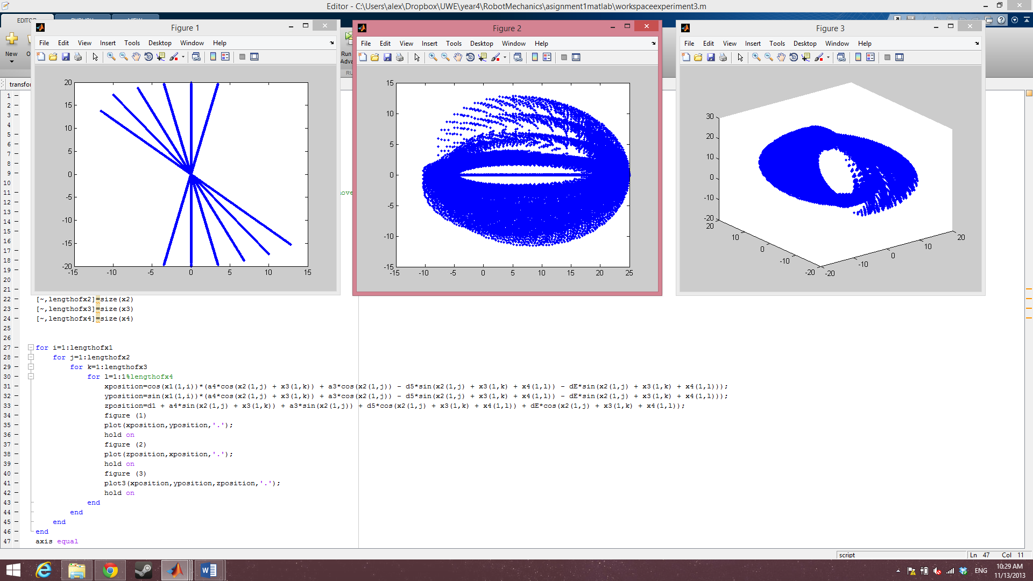

x,y

z,x

x,y,z

Figure 11

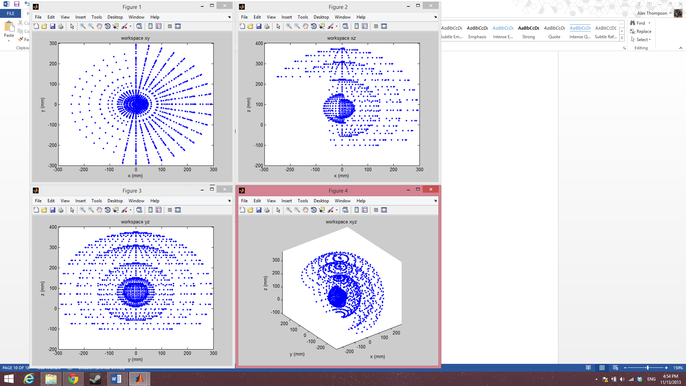 

Figure 13

Figure 12

 

Figure 15

Figure 14

### 2.4.2 Geometric Approach

The workspace can also be calculated geometrically. By defining circles with radius equal to the link length between each joint a theoretical arm can be moved around and define an outer and inner workspace. This allows for workspace calculation quickly by hand. The downside to this approach is that if the workspace is to be calculated in detail, for every additional joint added the complexity in calculating the workspace increases exponentially.

The end result of this is that this approach suffers from issues of granularity but it does allow a rough comparison to check the Matlab calculations. As this was only intended as a rough approximation the diagrams below are more aimed at the reach of an arm with joints and links similar to the lynxmotion arm, but lacking some of the same joint limitations.

Top view if joint 2 is fixed

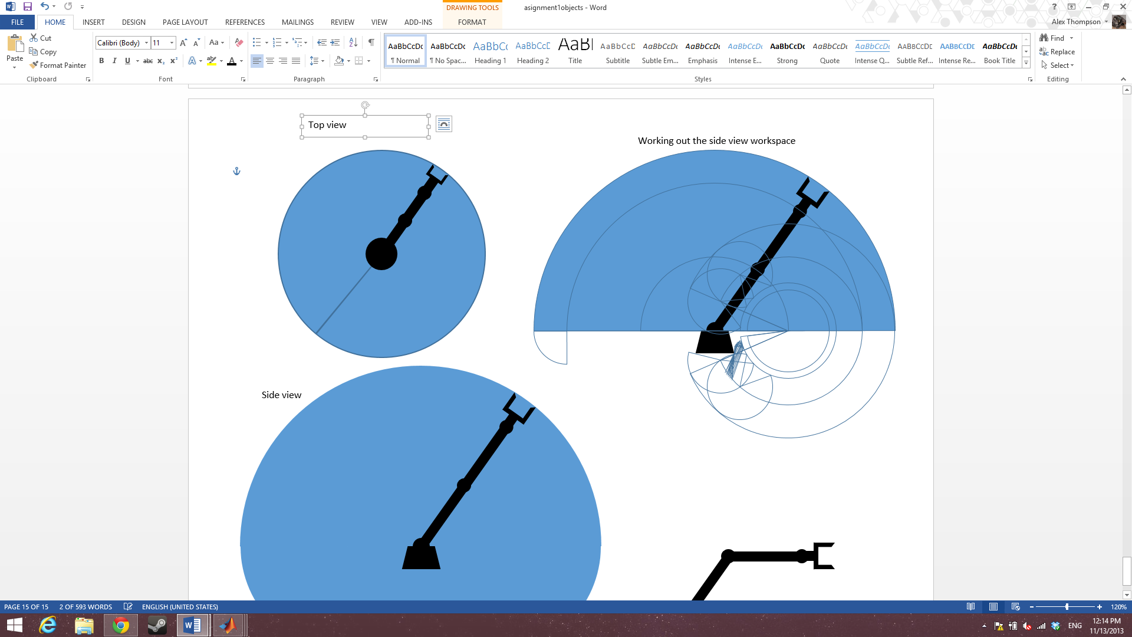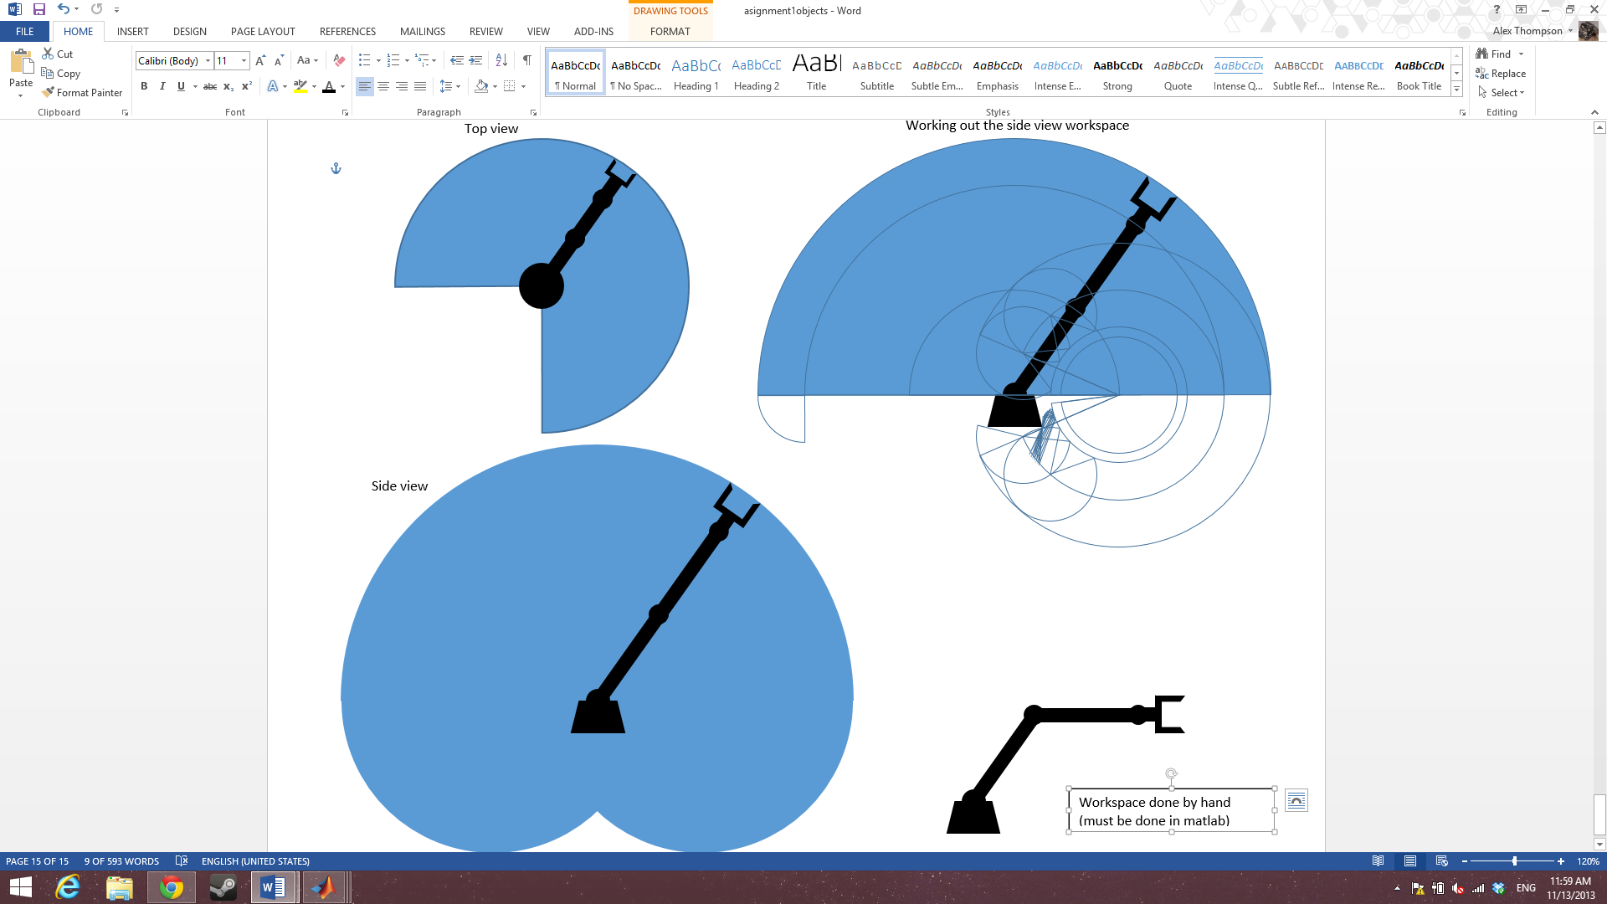

Figure 17

Figure 16

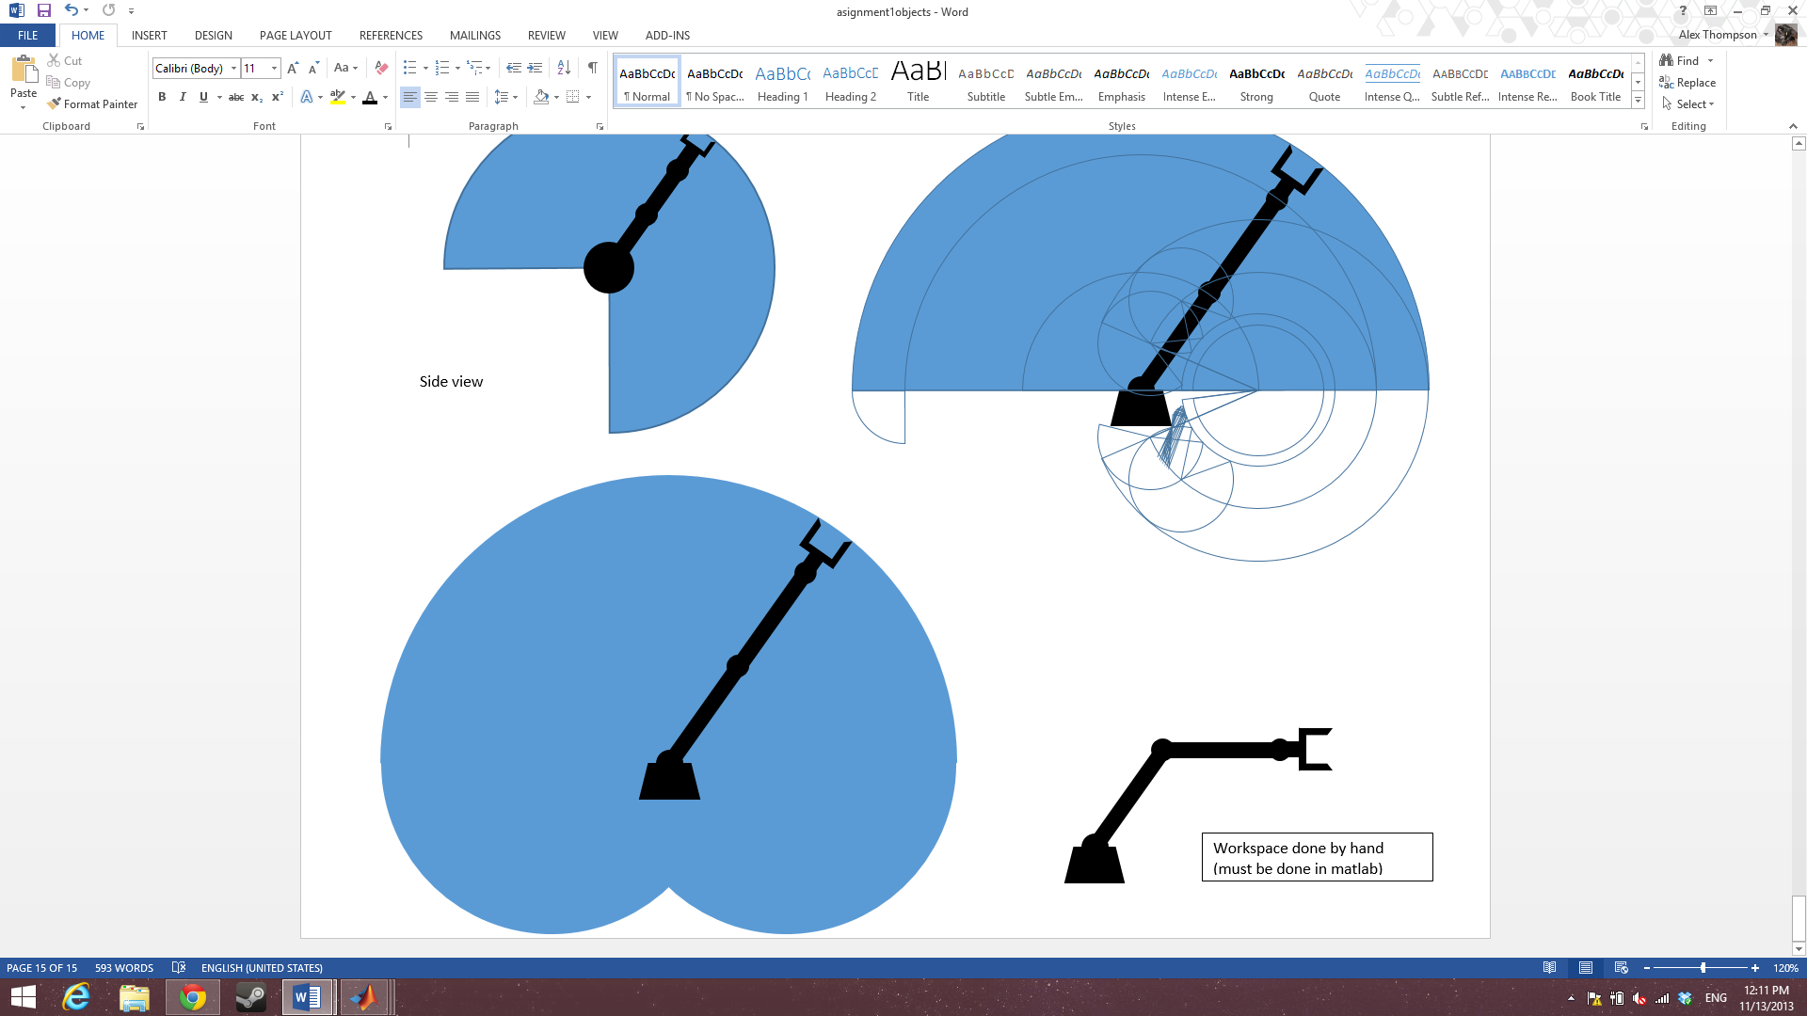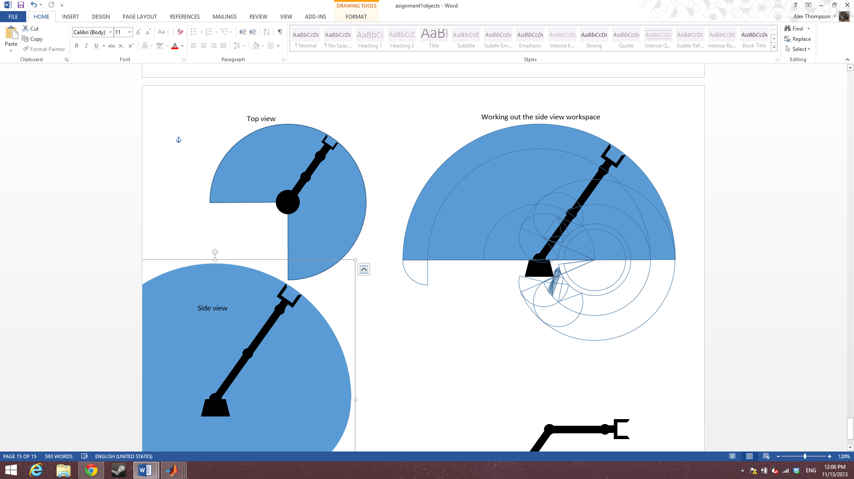

Front view using what was found from the side view

Figure 18

Working out the side view if joint 1 is unable to move

Figure 19

## 2.5 Inverse Kinematics

The inverse kinematics for a robot arm allow for the joint angles of the arm to be determined based on the position of the end effector. This can be done mathematically using the equations derived for the forward kinematics, or geometrically using the arm.

### 2.5.1 Mathematics

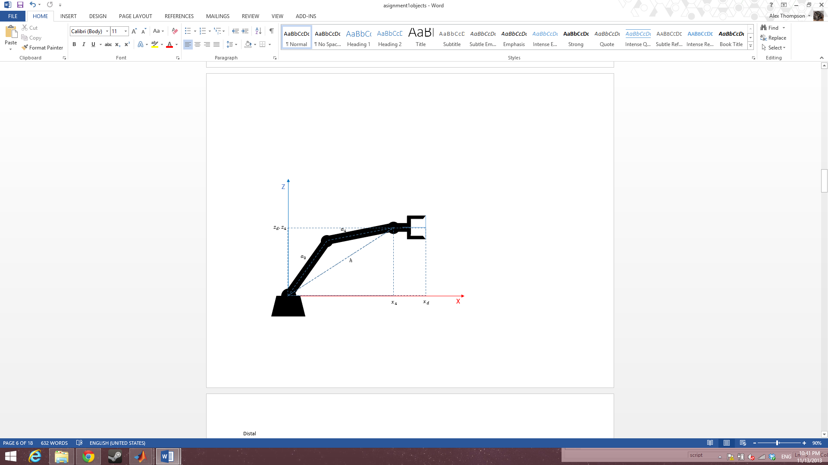A geometric approach was chosen.

See appendix 2.1 for trigonometric identities

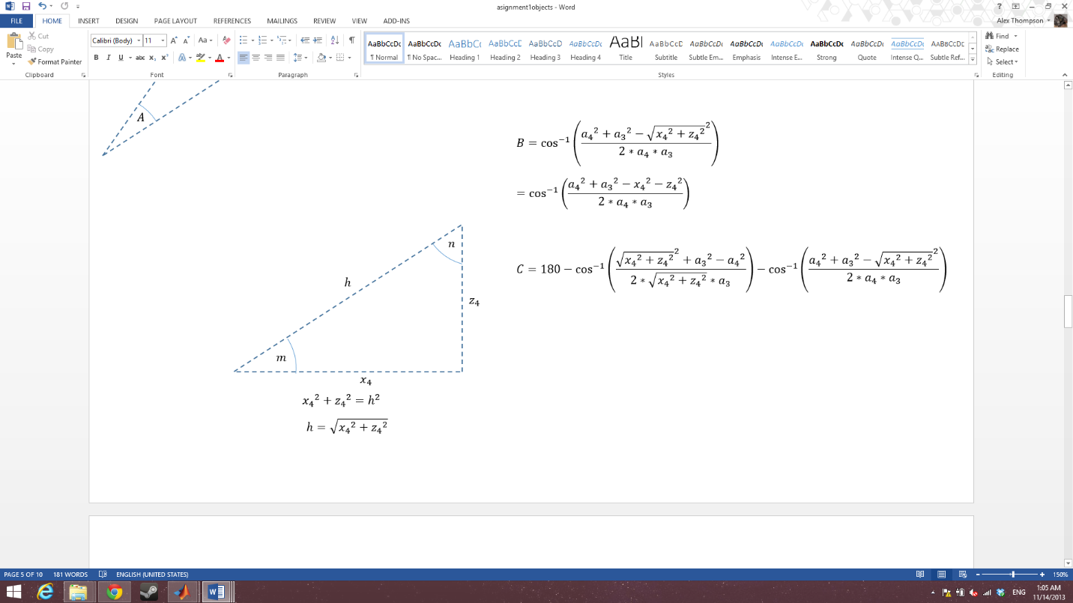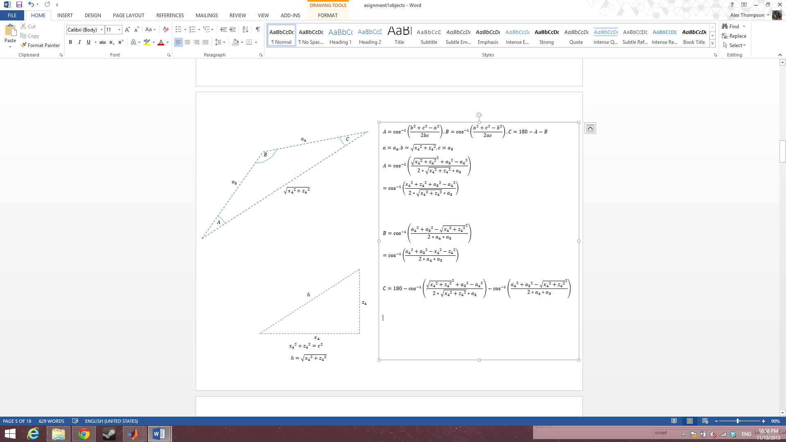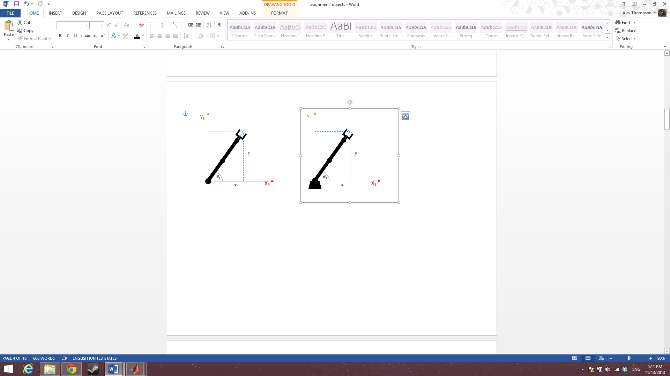

Figure 21

Figure 20

$$\tan{θ_{1}}=\frac{y}{x}$$

$$θ_{1}=\tan^{-1}\left(\frac{y}{x}\right)$$

Figure 22

Figure 23

$${x_{4}}^{2}+{z_{4}}^{2}=c^{2}$$

$$h=\sqrt{{x_{4}}^{2}+{z_{4}}^{2}}$$

$$m=\tan^{-1}\left(\frac{z_{4}}{x_{4}}\right)$$

$$n=\tan^{-1}\left(\frac{x_{4}}{z_{4}}\right)$$

$$a=a_{4}, b=\sqrt{{x_{4}}^{2}+{z_{4}}^{2}}, c=a_{3}$$

$$A=\cos^{-1}\left(\frac{{\sqrt{{x_{4}}^{2}+{z_{4}}^{2}}}^{2}+{a_{3}}^{2}-{a_{4}}^{2}}{2*\sqrt{{x_{4}}^{2}+{z_{4}}^{2}}*a_{3}}\right)$$

$$=\cos^{-1}\left(\frac{{x_{4}}^{2}+{z_{4}}^{2}+{a_{3}}^{2}-{a_{4}}^{2}}{2*\sqrt{{x_{4}}^{2}+{z_{4}}^{2}}*a_{3}}\right)$$

$$B=\cos^{-1}\left(\frac{{a_{4}}^{2}+{a_{3}}^{2}-{\sqrt{{x_{4}}^{2}+{z_{4}}^{2}}}^{2}}{2{*a}_{4}*a_{3}}\right)$$

$$=\cos^{-1}\left(\frac{{a_{4}}^{2}+{a_{3}}^{2}-{x_{4}}^{2}-{z_{4}}^{2}}{2{*a}_{4}*a_{3}}\right)$$

$$C=180-\cos^{-1}\left(\frac{{x_{4}}^{2}+{z_{4}}^{2}+{a_{3}}^{2}-{a_{4}}^{2}}{2*\sqrt{{x_{4}}^{2}+{z_{4}}^{2}}*a_{3}}\right)-\cos^{-1}\left(\frac{{a_{4}}^{2}+{a_{3}}^{2}-{x_{4}}^{2}-{z_{4}}^{2}}{2{*a}_{4}*a_{3}}\right)$$

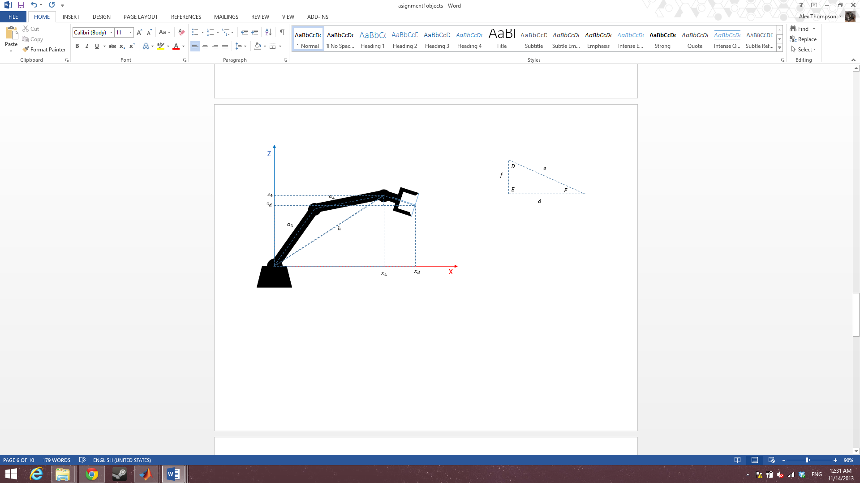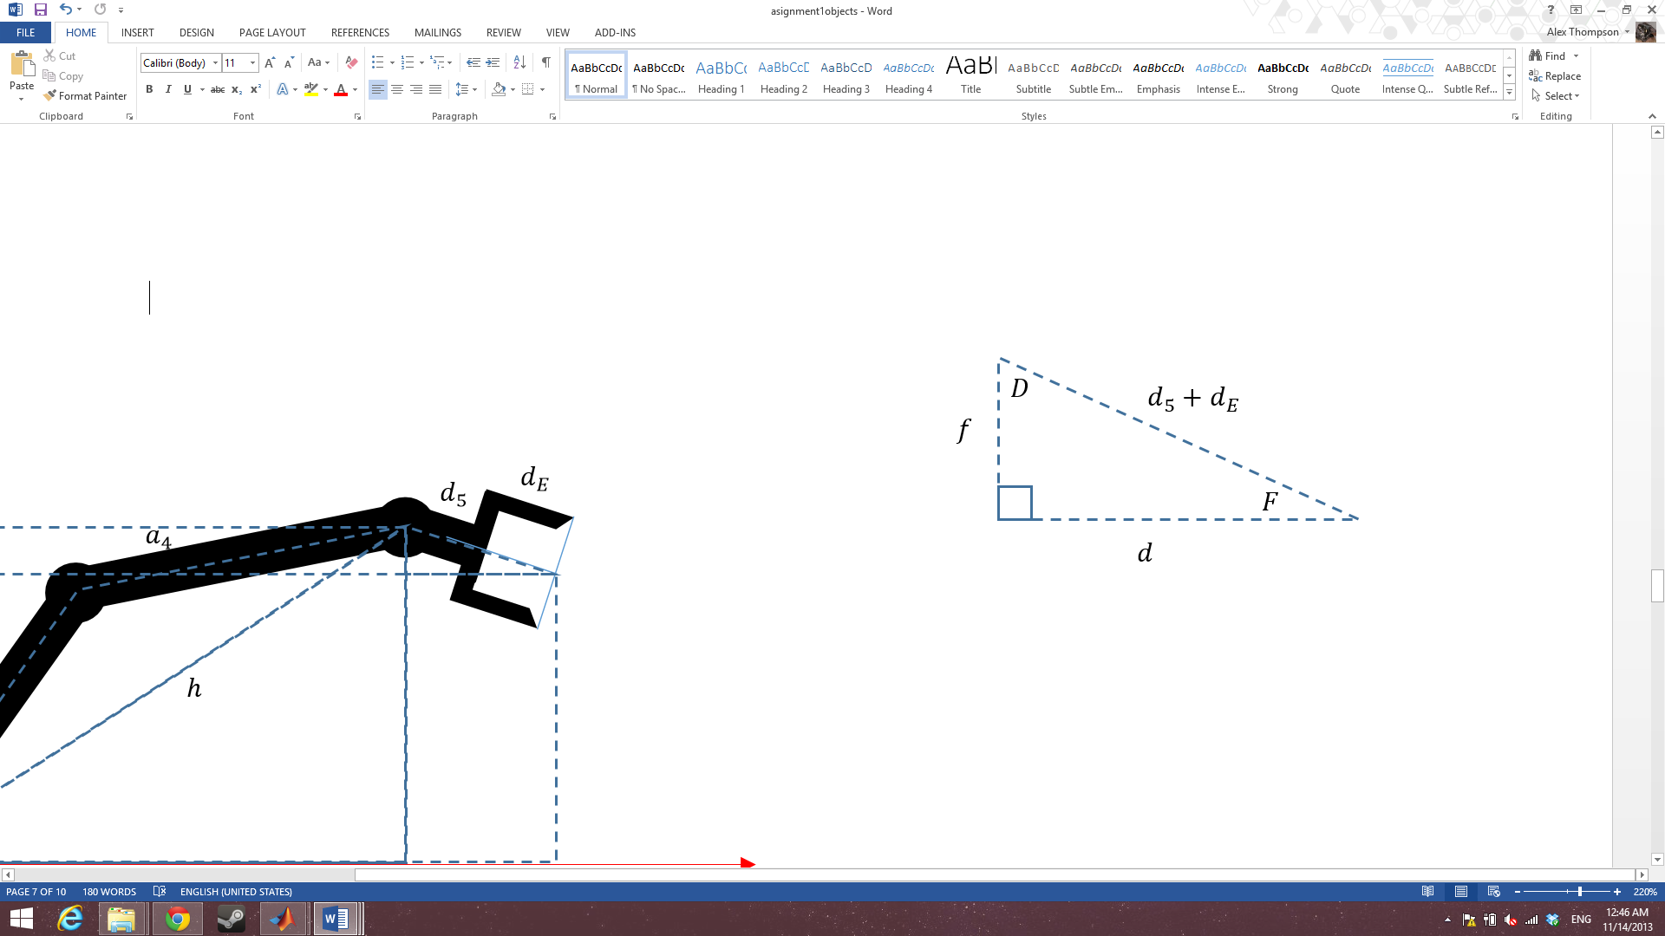

Figure 23

Figure 22

$$\sin{(F)}=\frac{f}{d_{5}+d_{E}}$$

$$f=\left(d_{5}+d_{E}\right)\sin{(F)}$$

$$\cos{(F)}=\frac{d}{d_{5}+d_{E}}$$

$$d=\left(d_{5}+d_{E}\right)\cos{(F)}$$

$$D=180-F-90=90-F$$

$$θ_{1}=\tan^{-1}\left(\frac{y}{x}\right)$$

$$θ_{2}=\cos^{-1}\left(\frac{{x_{4}}^{2}+{z_{4}}^{2}+{a_{3}}^{2}-{a_{4}}^{2}}{2*\sqrt{{x_{4}}^{2}+{z_{4}}^{2}}*a_{3}}\right)+\tan^{-1}\left(\frac{z_{4}}{x_{4}}\right)$$

$$θ_{3}=\cos^{-1}\left(\frac{{a_{4}}^{2}+{a_{3}}^{2}-{x_{4}}^{2}-{z_{4}}^{2}}{2{*a}_{4}*a_{3}}\right)$$

$$θ_{4}=C+\tan^{-1}\left(\frac{x_{4}}{z_{4}}\right)+90-F$$

$θ_{5}$ can be specified by the orientation required for the gripper

T04 = (input matrix)*[(T4e)-1].

(T4e)-1= Te4 =(T45*T5e)-1

T04 =

[ cos(x2 + x3 + x4)*cos(x1), -sin(x2 + x3 + x4)*cos(x1), sin(x1), cos(x1)*(a4*cos(x2 + x3) + a3*cos(x2))]

[ cos(x2 + x3 + x4)*sin(x1), -sin(x2 + x3 + x4)*sin(x1), -cos(x1), sin(x1)*(a4*cos(x2 + x3) + a3*cos(x2))]

[ sin(x2 + x3 + x4), cos(x2 + x3 + x4), 0, d1 + a4*sin(x2 + x3) + a3*sin(x2)]

[ 0, 0, 0, 1]

T4E =

[ cos(x4), -sin(x4), 0, a4]

[ sin(x4), cos(x4), 0, 0]

[ 0, 0, 1, dE]

[ 0, 0, 0, 1]

TE4 =

[ cos(x4)/(cos(x4)^2 + sin(x4)^2), sin(x4)/(cos(x4)^2 + sin(x4)^2), 0, -(a4*cos(x4))/(cos(x4)^2 + sin(x4)^2)]

[ -sin(x4)/(cos(x4)^2 + sin(x4)^2), cos(x4)/(cos(x4)^2 + sin(x4)^2), 0, (a4*sin(x4))/(cos(x4)^2 + sin(x4)^2)]

[ 0, 0, 1, -dE]

[ 0, 0, 0, 1]

This implementation of inverse kinematics treats the rotation of the base as y and then solves using x and z in a plane aligned by y.

### 2.5.2 Testing

The inverse kinematics were tested by simulating the arm in 3 positions (see appendix 1.5 for IK and 1.6 for generating visuals using IK).

As inverse kinematics allows for multiple solutions, a bias was placed on results that favored an elbow up stance.

Test 1

x= 109.0387; y= -29.7378; z= 397.1214;

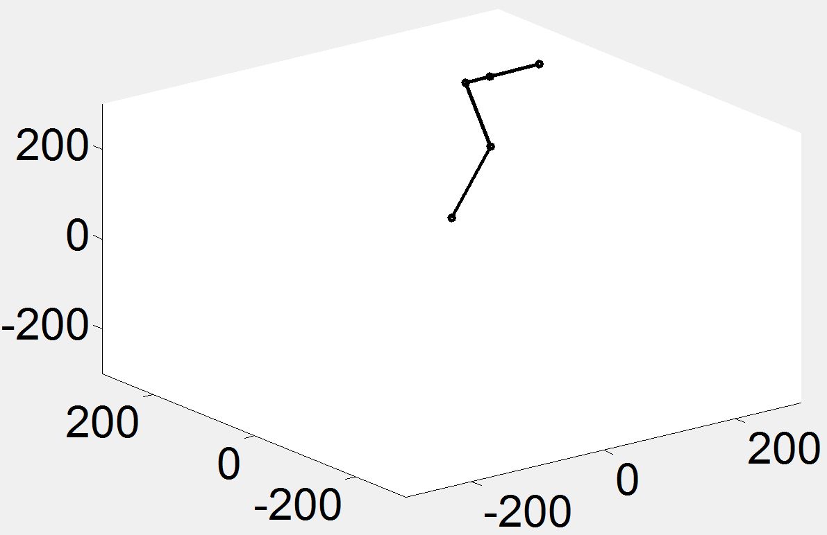

Figure 24

theta1= -15.2551; theta2= 71.2803; theta3= 30.9797; theta4=-180.0000; theta5=0.0000;

Test 2

x= 52.4868; y= -249.3123; z= 281.9260;

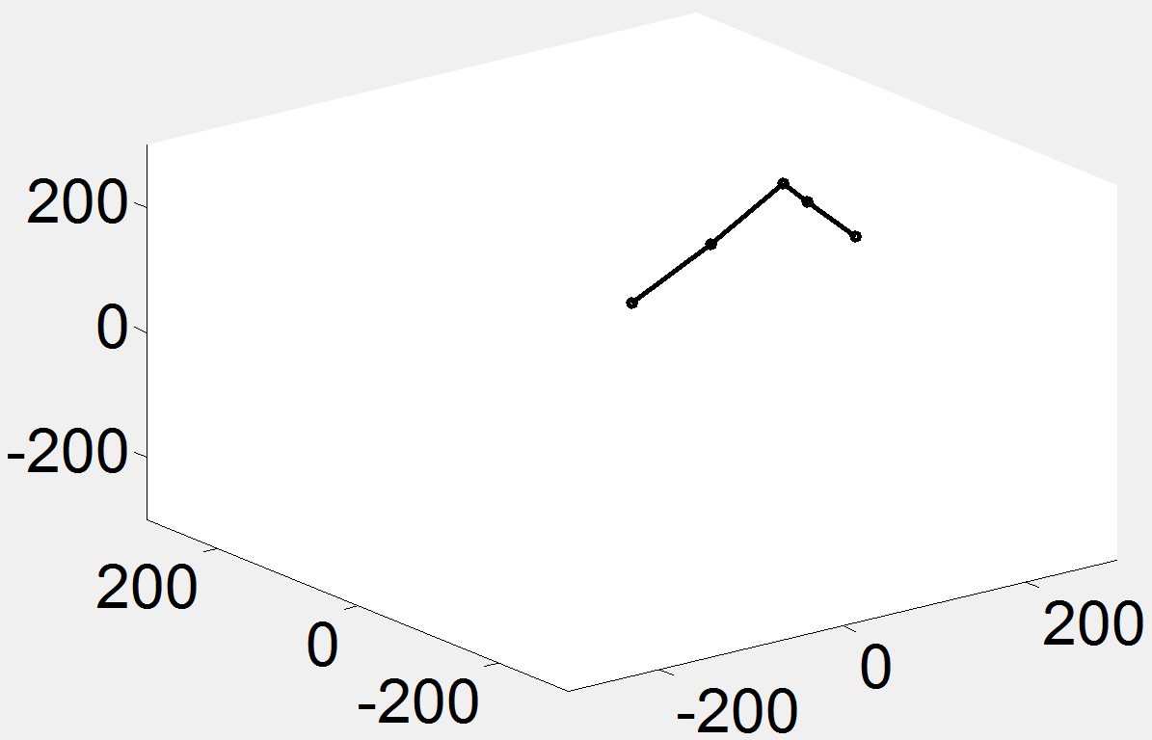

Figure 25

theta1= -78.1113; theta2= 54.7606; theta3= 2.3738; theta4=-180.0000; theta5=0.0000;

Test 3

x= 90.0598; y= 324.2153; z= 87.3623;

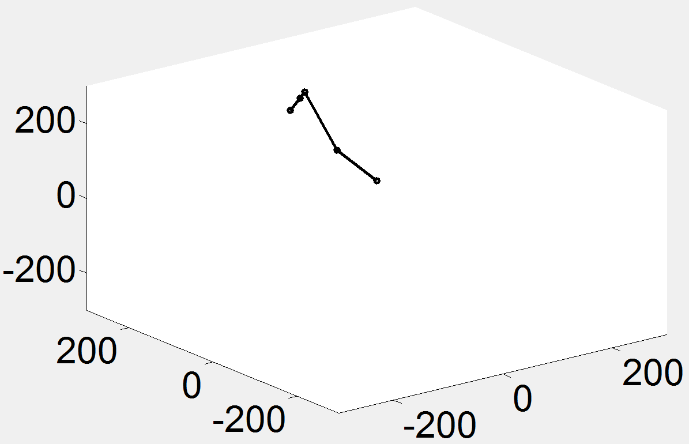

Figure 26

theta1= 74.4759; theta2= -0.4236; theta3= 35.7480; theta4=-180.0000; theta5=0.0000;

## 2.6 Task

### 2.6.1 Limit Testing

In order to plan and complete the task the limits of the arm were first tested using a modified runfile.py (appendix 1.7).

As can be seen in the code snippet (below) the values for each joint are passed in in the form of # *channel number* P *pwm value*.

**#SendCommands.execute( ["#5 P2000","#0 P2400 #1 P2400 #2 P2400 #3 P2400 #4 P2400 #5 P2400 T5000","wait 5"], options )**

Channel values set within the same command packet will execute simultaneously. An initial channel and pwm value must also be set that will not run simultaneous to the other channels. To get over this channel 5 (rotation of the gripper) gets set separate to the arm movement channels and can be respecified if need be within the same command packet. This allows for smooth movement of the arm to be maintained.

A time scale for the command packet can also be specified, as well as a length of time to wait before executing another command packet.

The result of this test can be seen here: <http://youtu.be/7zlRZFwArQA>

### 2.6.2 Task Plan

The task chosen is a pick and place task. It has the following format:

1. Initiate arm into home position
2. Move end effector above target object
3. Lower end effector onto target object
4. Grip target object
5. Move end effector up (bringing the object out of the way of obstacles)
6. Move end effector above target location
7. Lower end effector to place the object
8. Ungrip target object

### 2.6.3 IK and Simulation Positions

Home position

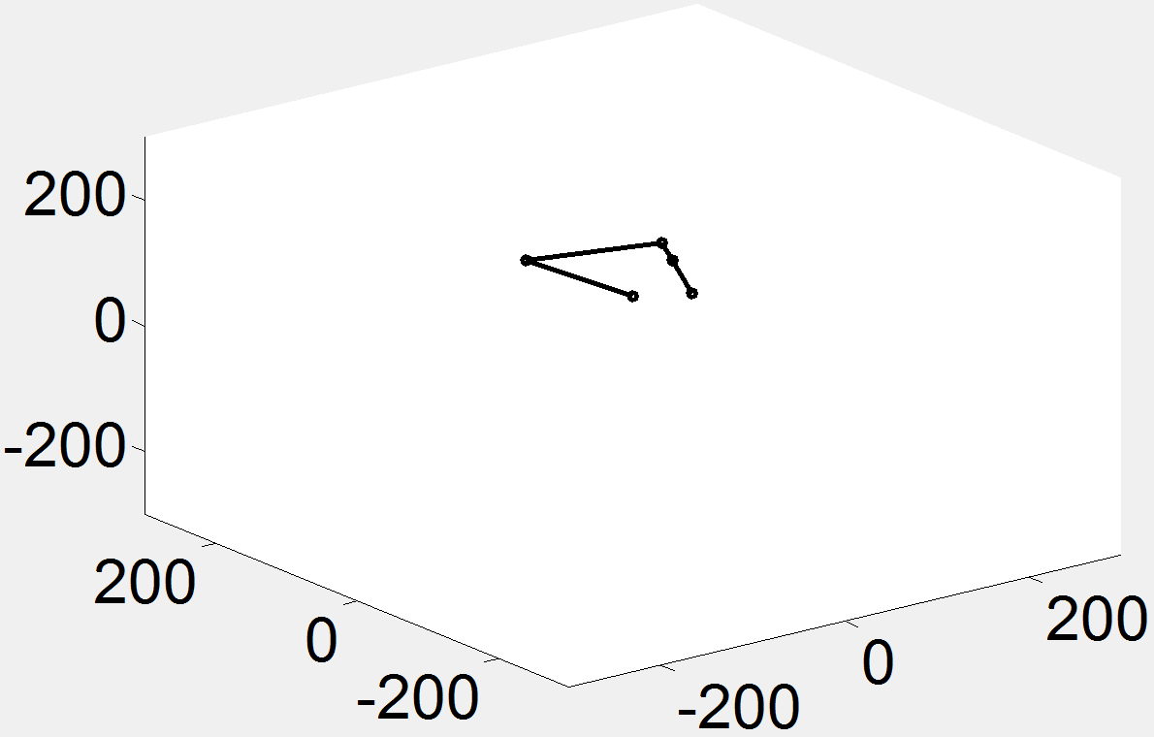

Figure 27

|  |  |  |  |
| --- | --- | --- | --- |
|  | **Input Coordinates** |  | **Output Angles** |
| X | 65.5632 | theta 1 | 1.6000 |
| Y | 1.8313 | theta 2 | 140 |
| Z | 60.0403 | theta 3 | -150.4000 |
|  |  | theta 4 | -149.4000 |
|  |  | theta 5 | 0 |

Above object

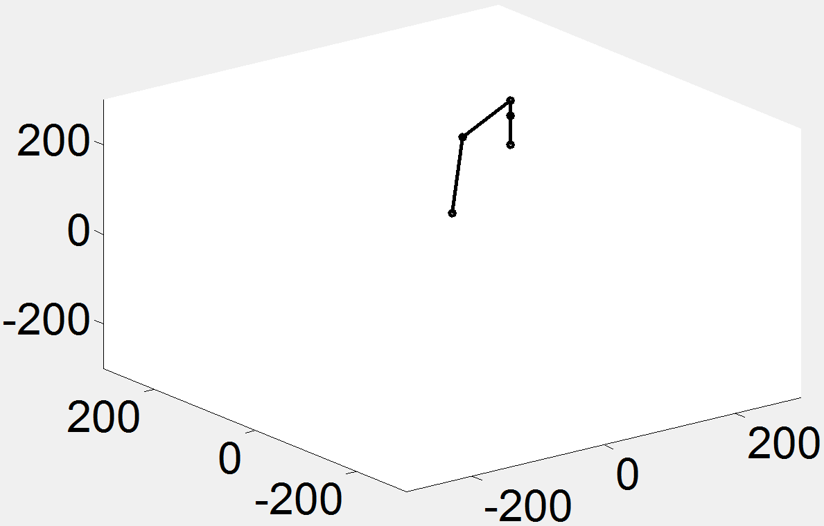

Figure 28

|  |  |  |  |
| --- | --- | --- | --- |
|  | **Input Coordinates** |  | **Output Angles** |
| X | 159.0090 | theta 1 | 30.3000 |
| Y | 92.9174 | theta 2 | 78.4000 |
| Z | 133.8342 | theta 3 | -78.4000 |
|  |  | theta 4 | -180 |
|  |  | theta 5 | 0 |

Grasping object

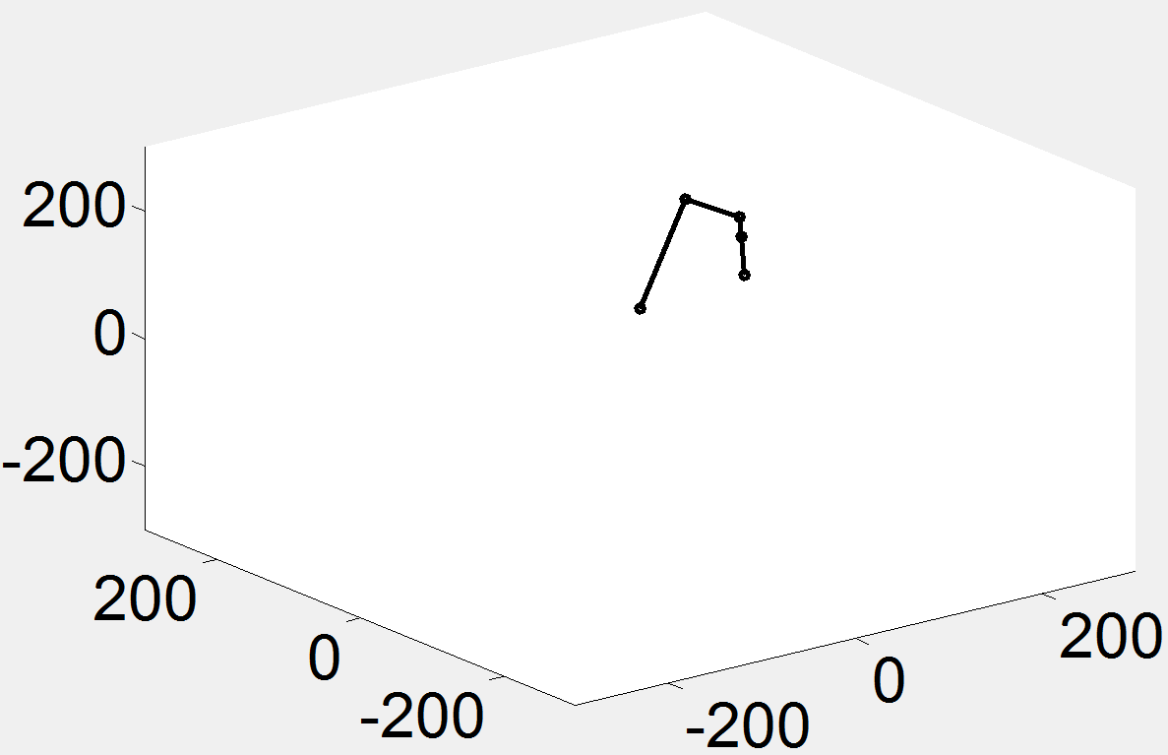

Figure 29

|  |  |  |  |
| --- | --- | --- | --- |
|  | **Input Coordinates** |  | **Output Angles** |
| X | 201.2904 | theta 1 | 30.3000 |
| Y | 117.6246 | theta 2 | 49.0000 |
| Z | 6.5532 | theta 3 | -86.4000 |
|  |  | theta 4 | -136.8000 |
|  |  | theta 5 | 0 |

Above end goal

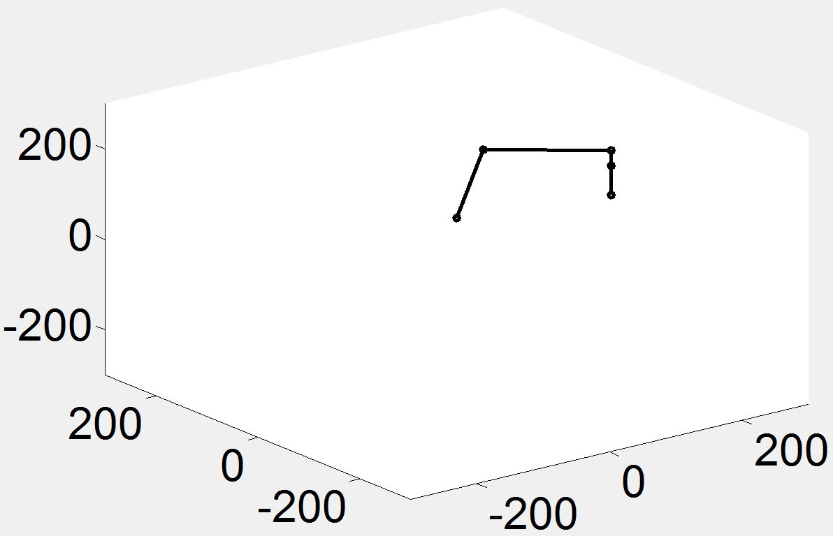

Figure 30

|  |  |  |  |
| --- | --- | --- | --- |
|  | **Input Coordinates** |  | **Output Angles** |
| X | 142.3121 | theta 1 | -39.4000 |
| Y | -116.8965 | theta 2 | 78.4000 |
| Z | 133.8342 | theta 3 | -78.4000 |
|  |  | theta 4 | -180 |
|  |  | theta 5 | 0 |

Releasing object

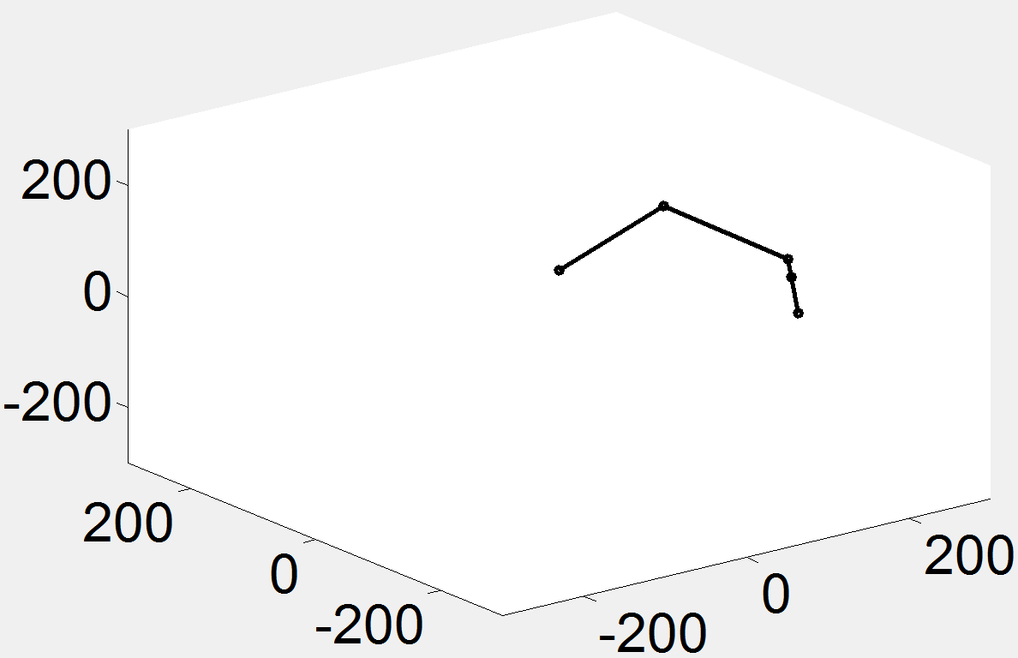

Figure 31

|  |  |  |  |
| --- | --- | --- | --- |
|  | **Input Coordinates** |  | **Output Angles** |
| X | 180.1536 | theta 1 | -39.4000 |
| Y | -147.9799 | theta 2 | 49.0000 |
| Z | 6.5532 | theta 3 | -86.4000 |
|  |  | theta 4 | -136.8000 |
|  |  | theta 5 | 0 |

## 2.7 Kinematics Summary

From the kinematics component of this assignment it was found that the best method for determining the transformation matrices based on the DH table was to use the generalized equation. To map the workspace a geometric approach proved to be initially quite easy to implement but became quite complicated to manage with each addition of a joint. Plot the workspace in Matlab using the end effector positions obtained from the forward kinematics proved to be a better method, those this system can also suffer from the curse of dimensionality. For solving the inverse kinematics two possible methods were encountered (algebraic and geometric). For the purpose of this report it was decided to utilize the geometric approach as visualizing the problem helped to break it down.

# Intelligence

This section focuses on generating an Adaptive Neuro-Fuzzy Interface System (ANFIS) representation of the inverse kinematics of a lynxmotion arm.

As the first component to this section an exploration is undertaken for 2 joint arms to determine speed and accuracy differences between various techniques. This allows faster exploration as running these simulations for the full lynxmotion arm would take quite some time.

## 3.1 Investigation

### 3.1.1 Comparing ANFIS and GENFIS

Just ANFIS

The training took 16 seconds for the first network and 9 seconds for the second network (one network for each joint). To determine the error margins the results of the ANFIS networks were compared with the inverse kinematics for the system. The error margins are shown below.

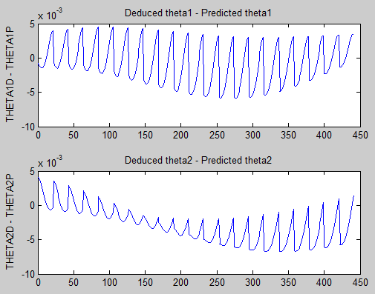

Figure 32

GENFIS2 cleaned up with ANFIS

The training took about 2 seconds for the first net and 2 seconds for the second net.

Below, error is shown for training and checking. The checking set is produced in a similar manner to the training set, but the checking set has fewer values (roughly 25% of the values). Ideally these values are randomly spread over the values to give an accurate idea of how well the training went and detect things like overtraining.

The top graphs are theta1 and the bottom are theta2.

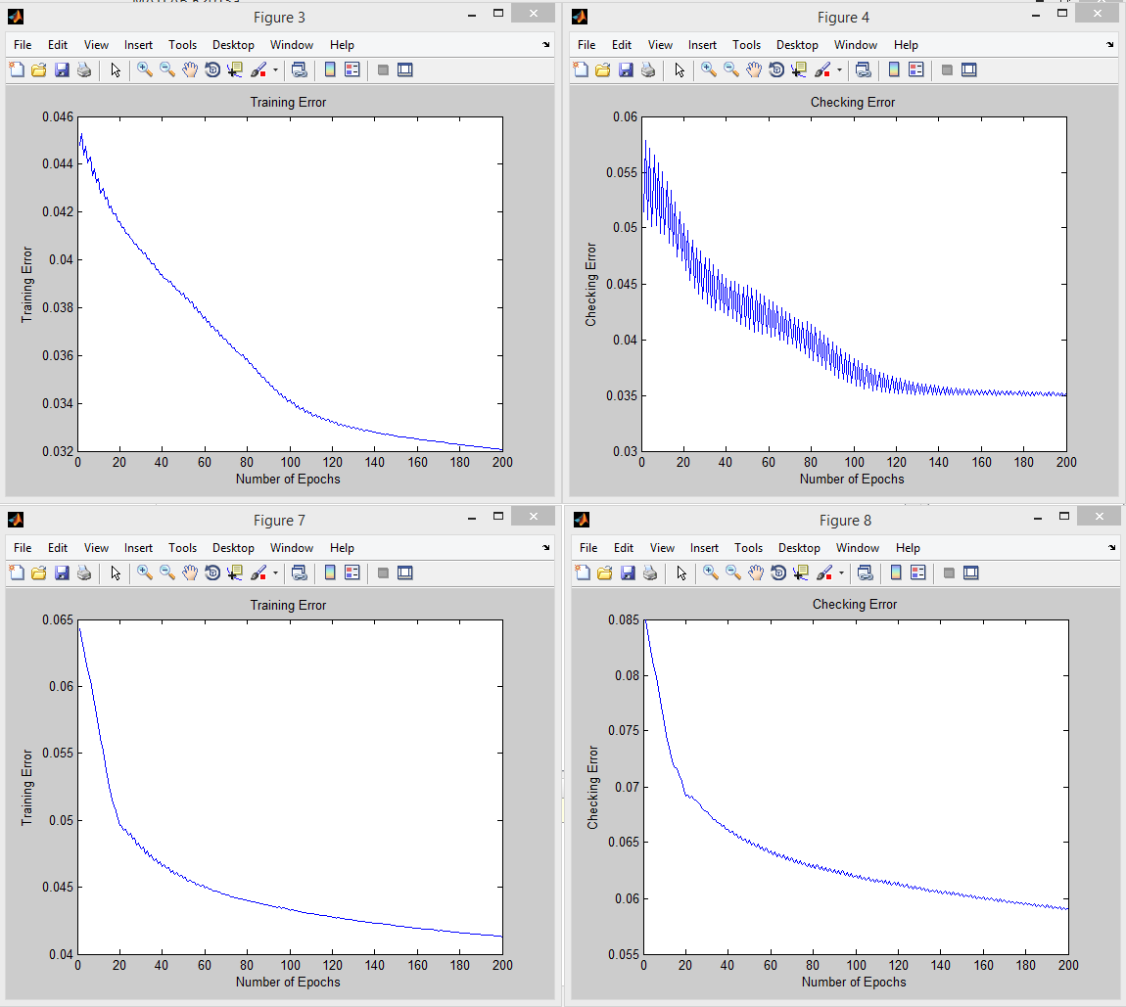

Figure 33

Below, a comparison is shown of just GENFIS2 on the left and using ANFIS to clean up after GENFIS2 on the right. The dots are the checking set of data, the closer they line up to the lines, the more accurate the system is.

The top graphs are theta1 and the bottom are theta2.

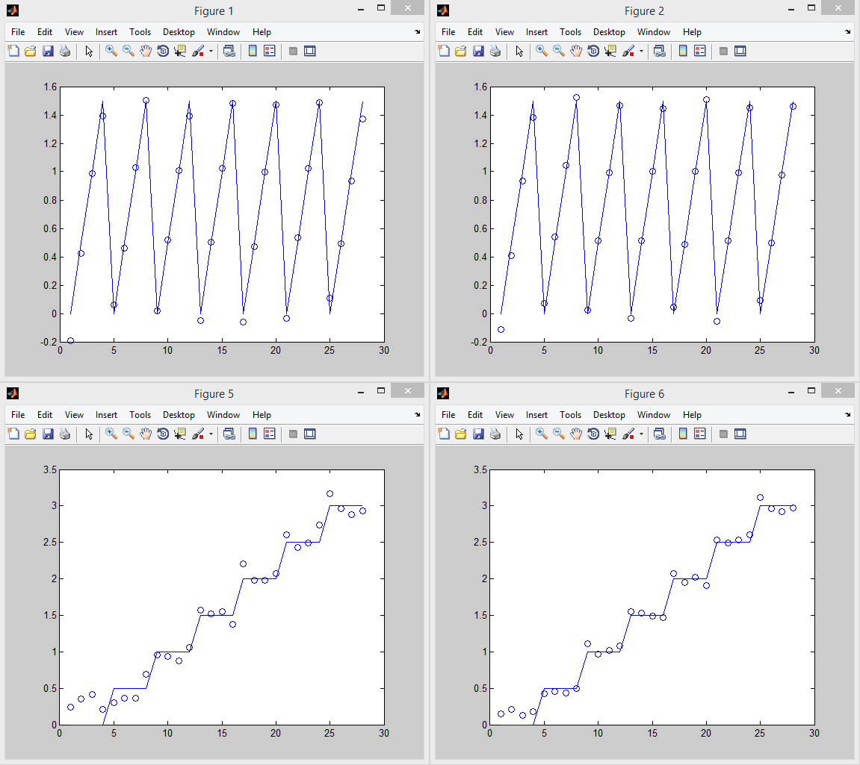

Figure 34

From this it is quite noticable that genfis2 will allow for much faster construction of ANFIS networks, but that anfis can provide some important improvements on the model.

### 3.1.2 Over and Under Classification

An issue that can be encountered is balancing the resolution of genfis and anfis. If not enough resolution is given then the problem can be under classified. If too much is given then it can be over classified (and take quite a while to run). An example of too little resolution is shown below.

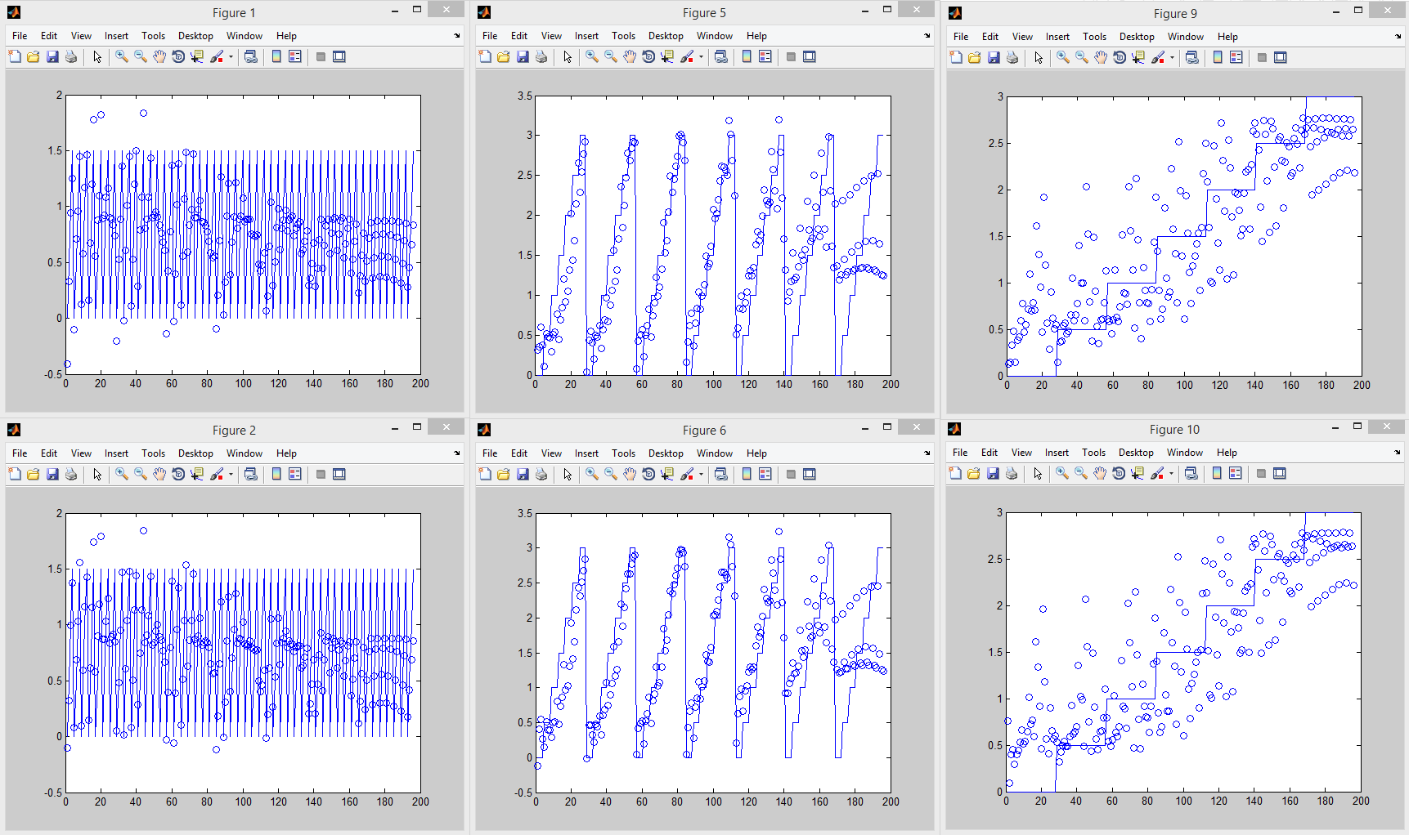

Figure 35

## 3.2 Inverse Kinematics

To reduce the amount of computation required the first joint (rotation of the base) has been separated from training. This allows for a 3 joint planar arm to be simulated. The rotation is

genfis2 radii = .05,

chck fuzout against chck dataout, theta2 on the left, theta3 on the right

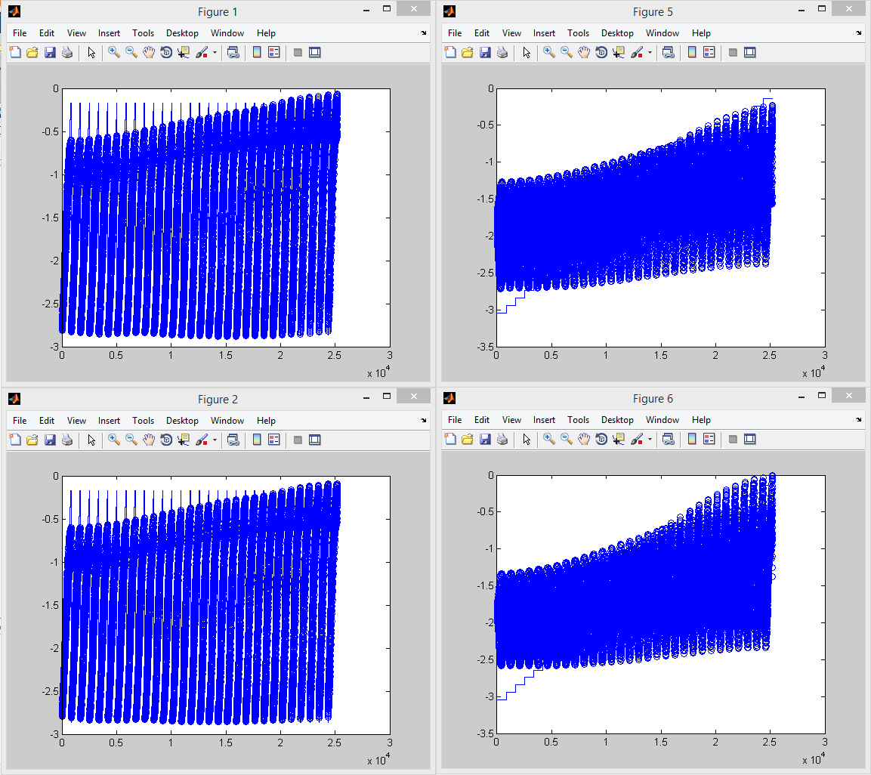

Figure 36

training and checking errors, theta2 on the left, theta3 on the right

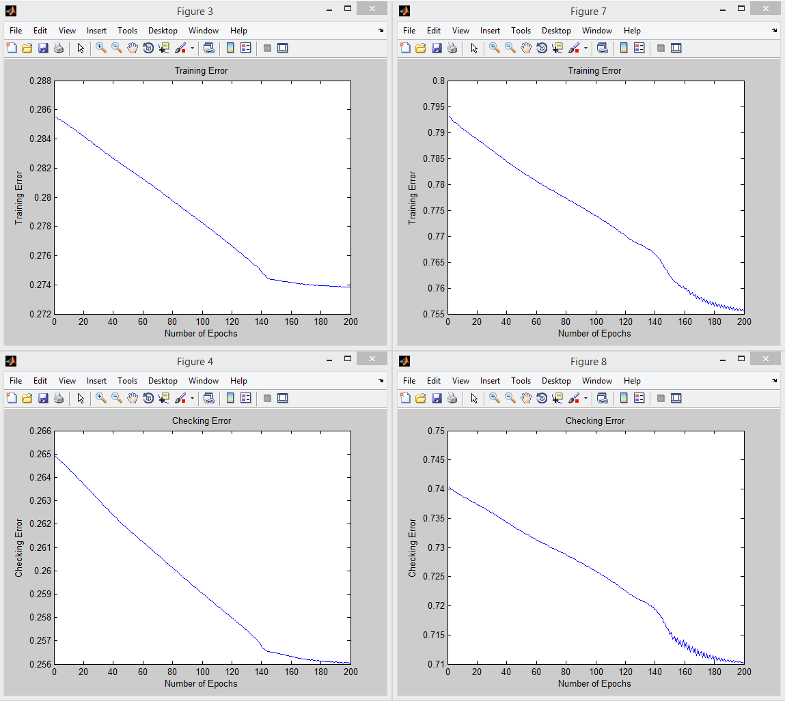

Figure 37

# Expansion

## 4.1 GUI Arm Simulation

### 4.1.1 How it Works

A graphical user interface was created for control of a simulated lynxmotion arm. The interface allows for quick visualization of forward and inverse kinematics. The code can be found in appendix 1.6.

Users have an option of updating the arm plot via the update button or by activating live mode. The update button has a drop down for choosing between forward and inverse kinematics.

While in live mode, the system defaults to whichever slider group was update last. So if something is adjusted in the FK sliders, the system will use fk to display the simulated arm, the same goes for IK.

Prebuilt positions have also been provided which are currently set similar to the positions for the pick and place task that was chosen for section 2.6 above.

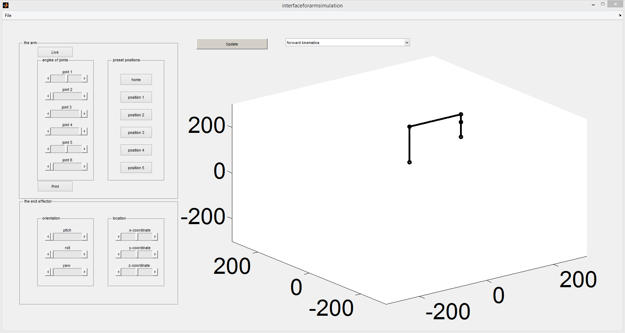

Figure 38

### 4.1.2 Limitations and Future Work

The pitch, roll, and yaw sliders have not yet been implemented. Also, A system for warning users when they are attempting to move the arm into an illegal position (outside the bounds the arm could move) would greatly improve its usefulness.

A further expansion would be to build up the simulation further to include gravity, velocity, and comms to the lynxmotion arm. This would allow the interface to be used to fully simulate what a user wanted to do with a lynxmotion arm and then export that to the arm once they were happy with it. Such a system would reduce demand for the arms and reduce the need for repairs as erratic moves would become obvious in the simulation.

# Appendix

## Matlab Code

note, most Matlab code based on work by Antonia Tzemanaki (Tzemanaki, n.d.)

### 1.1 Solving T1E Using Matlab:

syms x1 x2 x3 x4 x5 a3 a4 d1 d5 dE

T1=[cos(x1) –sin(x1) 0 0;sin(x1) cos(x1) 0 0;0 0 1 d1;0 0 0 1];

T2=[cos(x2) –sin(x2) 0 0;0 0 -1 0;sin(x2) cos(x2) 0 0;0 0 0 1];

T3=[cos(x3) –sin(x3) 0 a3;sin(x3) cos(x3) 0 0;0 0 1 0;0 0 0 1];

T4=[cos(x4) –sin(x4) 0 a4;sin(x4) cos(x4) 0 0;0 0 1 0;0 0 0 1];

T5=[cos(x5) –sin(x5) 0 0;0 0 1 d5;-sin(x5) -cos(x5) 0 0;0 0 0 1];

TE=[1 0 0 0; 0 1 0 0;0 0 1 dE;0 0 0 1];

T1E=simplify(T1*T2*T3*T4*T5*TE);

Output is

[ cos(x2 + x3 + x4)*cos(x1)*cos(x5) - sin(x1)*sin(x5), - cos(x5)*sin(x1) - cos(x2 + x3 + x4)*cos(x1)*sin(x5), -sin(x2 + x3 + x4)*cos(x1), cos(x1)*(a4*cos(x2 + x3) + a3*cos(x2) - d5*sin(x2 + x3 + x4) - dE*sin(x2 + x3 + x4))]

[ cos(x1)*sin(x5) + cos(x2 + x3 + x4)*cos(x5)*sin(x1), cos(x1)*cos(x5) - cos(x2 + x3 + x4)*sin(x1)*sin(x5), -sin(x2 + x3 + x4)*sin(x1), sin(x1)*(a4*cos(x2 + x3) + a3*cos(x2) - d5*sin(x2 + x3 + x4) - dE*sin(x2 + x3 + x4))]

[ sin(x2 + x3 + x4)*cos(x5), -sin(x2 + x3 + x4)*sin(x5), cos(x2 + x3 + x4), d1 + a4*sin(x2 + x3) + a3*sin(x2) + d5*cos(x2 + x3 + x4) + dE*cos(x2 + x3 + x4)]

[ 0, 0, 0, 1]

### 1.2 Testing the Forward Kinematics

theta1=-80; %from -100 to 90 degrees

theta2=90; %from 0 to 180 degrees

theta3=-90; %from 0 to -170 degrees

theta4=-180; %from -180 to 0 degrees

theta5=50; %from 0 to 180 degrees

x1 = theta1*pi/180;

x2 = theta2*pi/180;

x3 = theta3*pi/180;

x4 = theta4*pi/180;

x5 = theta5*pi/180;

d1=80;

a3=155;

a4=153;

d5=33;

dE=65;

T1=[cos(x1) –sin(x1) 0 0;sin(x1) cos(x1) 0 0;0 0 1 d1;0 0 0 1];

T2=[cos(x2) –sin(x2) 0 0;0 0 -1 0;sin(x2) cos(x2) 0 0;0 0 0 1];

T3=[cos(x3) –sin(x3) 0 a3;sin(x3) cos(x3) 0 0;0 0 1 0;0 0 0 1];

T4=[cos(x4) –sin(x4) 0 a4;sin(x4) cos(x4) 0 0;0 0 1 0;0 0 0 1];

T5=[cos(x5) –sin(x5) 0 0;0 0 1 d5;-sin(x5) -cos(x5) 0 0;0 0 0 1];

TE=[cos(xE) –sin(xE) 0 0; sin(xE) cos(xE) 0 0;0 0 1 dE;0 0 0 1];

T1E= T1*T2*T3*T4*T5*TE;

Output is

T1E =

0.0000 0 -1.0000 -71.0000

0 1.0000 0 0

1.0000 0 0.0000 317.0000

0 0 0 1.0000

### 1.3 Calculating the workspace

clear all

close all

clc

d1=80;

a3=155;

a4=153;

d5=33;

dE=65;

x1=(-100*pi)/180:pi/18:pi/2; %from -100 to 90 degrees with an increment size of pi/18

x2=0:pi/18:pi; %from 0 to 180 degrees with an increment size of pi/18

x3=-pi+((10*pi)/180):pi/5:0; %from 0 to -170 degrees with an increment size of pi/5

x4=-pi:pi/2:0; %from -180 to 0 degrees with an increment size of pi/2

x5=0; %set to 0 as its rotation won’t affect the position of

%the end effector, just its orientation.

xposition=zeros(360,360);

yposition=zeros(360,360);

zposition=zeros(360,360);

[~,lengthofx1]=size(x1);

[~,lengthofx2]=size(x2);

[~,lengthofx3]=size(x3);

[~,lengthofx4]=size(x4);

for i=1:lengthofx1

for j=1:lengthofx2

for k=1:lengthofx3

for l=1:1%lengthofx4

xposition=cos(x1(1,i))*(a4*cos(x2(1,j) + x3(1,k)) + a3*cos(x2(1,j)) - d5*sin(x2(1,j) + x3(1,k) + x4(1,l)) - dE*sin(x2(1,j) + x3(1,k) + x4(1,l)));

yposition=sin(x1(1,i))*(a4*cos(x2(1,j) + x3(1,k)) + a3*cos(x2(1,j)) - d5*sin(x2(1,j) + x3(1,k) + x4(1,l)) - dE*sin(x2(1,j) + x3(1,k) + x4(1,l)));

zposition=d1 + a4*sin(x2(1,j) + x3(1,k)) + a3*sin(x2(1,j)) + d5*cos(x2(1,j) + x3(1,k) + x4(1,l)) + dE*cos(x2(1,j) + x3(1,k) + x4(1,l));

figure (1)

plot(xposition,yposition,'.');

hold on

title('workspace xy') ; xlabel('x (mm)') ; ylabel('y (mm)'); zlabel('z (mm)') ;

figure (2)

plot(xposition,zposition,'.');

hold on

title('workspace xz') ; xlabel('x (mm)') ; ylabel('z (mm)');

figure (3)

plot(yposition,zposition,'.');

hold on

title('workspace yz') ; xlabel('y (mm)') ; ylabel('z (mm)');

figure (4)

plot3(xposition,yposition,zposition,'.');

hold on

title('workspace xyz') ; xlabel('x (mm)') ; ylabel('y (mm)'); zlabel('z (mm)') ;

end

end

end

end

axis equal

### 1.4 Simulating the Arm

%%%%%%%%%%%%% Alex Thompson %%%%%%%%%%%

clear all

close all

clc

%% A series of joint angles

% different positions of x

theta1=30; %from -100 to 90 degrees

theta2=58; %from 0 to 180 degrees

theta3=-78; %from 0 to -170 degrees

theta4=-180; %from -180 to 0 degrees

theta5=0; %from 0 to 180 degrees

q1 = theta1*pi/180;

q2 = theta2*pi/180;

q3 = theta3*pi/180;

q4 = theta4*pi/180;

q5 = theta5*pi/180;

%% Link Lengths

d1 = 80;

a3 = 155;

a4 = 153;

d5 = 33;

dE = 65;

%% Plot the robotic arm

x0 = 0;

y0 = 0;

z0 = d1;

x1 = 0 ;

y1 = 0 ;

z1 = d1 ;

x2 = a3*cos(q1)*cos(q2);

y2 = a3*cos(q2)*sin(q1);

z2 = d1 + a3*sin(q2);

x3= cos(q1)*(a4*cos(q2 + q3) + a3*cos(q2));

y3= sin(q1)*(a4*cos(q2 + q3) + a3*cos(q2));

z3= d1 + a4*sin(q2 + q3) + a3*sin(q2);

x4 = cos(q1)*(a4*cos(q2 + q3) + a3*cos(q2) - d5*sin(q2 + q3 + q4));

y4 = sin(q1)*(a4*cos(q2 + q3) + a3*cos(q2) - d5*sin(q2 + q3 + q4));

z4 = d1 + a4*sin(q2 + q3) + a3*sin(q2) + d5*cos(q2 + q3 + q4);

xe = cos(q1)*(a4*cos(q2 + q3) + a3*cos(q2) - (d5+dE)*sin(q2 + q3 + q4))

ye = sin(q1)*(a4*cos(q2 + q3) + a3*cos(q2) - (d5+dE)*sin(q2 + q3 + q4))

ze = d1 + a4*sin(q2 + q3) + a3*sin(q2) + (d5+dE)*cos(q2 + q3 + q4)

i=1;

xx = [ x0(i); x1(i); x2(i); x3(i); x4(i); xe(i) ];

yy = [ y0(i); y1(i); y2(i); y3(i); y4(i); ye(i) ];

zz = [ z0(i); z1(i); z2(i); z3(i); z4(i); ze(i) ];

plot3(xx,yy,zz,'ko-','Linewidth',4)

axis equal

hold on

title('arm simulation'); xlabel('x (mm)') ; ylabel('y (mm)'); zlabel('z (mm)');

### 1.5 Testing Inverse Kinematics

d1=0;

a3=155;

a4=153;

d5=33;

dE=65;

x4=185; %needs to be fixed when xd is determined

z4=133+(d5+dE)-d1; %needs to be fixed when zd is determined

C=180-acos((x4^2+z4^2+a3^2-a4^2)/(2*a3*sqrt(x4^2+z4^2+a3)))-acos((a4^2+a3^2-x4^2-z4^2)/(2*a4*a3));

theta2=acos((x4^2+z4^2+a3^2-a4^2)/(2*a3*sqrt(x4^2+z4^2+a3)))+atan(z4/x4);

theta3=acos((a4^2+a3^2-x4^2-z4^2)/(2*a4*a3));

%theta4=C+atan(x4/z4)+90-F

theta2*180/pi

theta3*180/pi

### 1.6 GUI interface

function varargout = interfaceforarmsimulation(varargin)

% INTERFACEFORARMSIMULATION MATLAB code for interfaceforarmsimulation.fig

% INTERFACEFORARMSIMULATION, by itself, creates a new INTERFACEFORARMSIMULATION or raises the existing

% singleton*.

%

% H = INTERFACEFORARMSIMULATION returns the handle to a new INTERFACEFORARMSIMULATION or the handle to

% the existing singleton*.

%

% INTERFACEFORARMSIMULATION('CALLBACK',hObject,eventData,handles,...) calls the local

% function named CALLBACK in INTERFACEFORARMSIMULATION.M with the given input arguments.

%

% INTERFACEFORARMSIMULATION('Property','Value',...) creates a new INTERFACEFORARMSIMULATION or raises the

% existing singleton*. Starting from the left, property value pairs are

% applied to the GUI before interfaceforarmsimulation_OpeningFcn gets called. An

% unrecognized property name or invalid value makes property application

% stop. All inputs are passed to interfaceforarmsimulation_OpeningFcn via varargin.

%

% *See GUI Options on GUIDE's Tools menu. Choose "GUI allows only one

% instance to run (singleton)".

%

% See also: GUIDE, GUIDATA, GUIHANDLES

% Edit the above text to modify the response to help interfaceforarmsimulation

% Last Modified by GUIDE v2.5 18-Dec-2014 07:54:33

% Begin initialization code - DO NOT EDIT

gui_Singleton = 1;

gui_State = struct('gui_Name', mfilename, ...

'gui_Singleton', gui_Singleton, ...

'gui_OpeningFcn', @interfaceforarmsimulation_OpeningFcn, ...

'gui_OutputFcn', @interfaceforarmsimulation_OutputFcn, ...

'gui_LayoutFcn', [] , ...

'gui_Callback', []);

if nargin && ischar(varargin{1})

gui_State.gui_Callback = str2func(varargin{1});

end

if nargout

[varargout{1:nargout}] = gui_mainfcn(gui_State, varargin{:});

else

gui_mainfcn(gui_State, varargin{:});

end

% End initialization code - DO NOT EDIT

% --- Executes just before interfaceforarmsimulation is made visible.

function interfaceforarmsimulation_OpeningFcn(hObject, eventdata, handles, varargin)

% This function has no output args, see OutputFcn.

% hObject handle to figure

% eventdata reserved - to be defined in a future version of MATLAB

% handles structure with handles and user data (see GUIDATA)

% varargin command line arguments to interfaceforarmsimulation (see VARARGIN)

% Choose default command line output for interfaceforarmsimulation

handles.output = hObject;

handles.metricdata.joint1 = 0;

handles.metricdata.joint2 = 0;

handles.metricdata.joint3 = 0;

handles.metricdata.joint4 = 0;

handles.metricdata.joint5 = 0;

handles.metricdata.toggleliveforwardkinematics = 0;

handles.metricdata.xcoordinate = 0;

handles.metricdata.ycoordinate = 0;

handles.metricdata.zcoordinate = 0;

set(handles.joint1, 'String', handles.metricdata.joint1);

set(handles.joint2, 'String', handles.metricdata.joint2);

set(handles.joint3, 'String', handles.metricdata.joint3);

set(handles.joint4, 'String', handles.metricdata.joint4);

set(handles.joint5, 'String', handles.metricdata.joint5);

set(handles.xcoordinate, 'String', handles.metricdata.xcoordinate);

set(handles.ycoordinate, 'String', handles.metricdata.ycoordinate);

set(handles.zcoordinate, 'String', handles.metricdata.zcoordinate);

%set(handles.toggleliveforward, 'String', handles.metricdata.toggleliveforward);

% Update handles structure

guidata(hObject, handles);

% This sets up the initial plot - only do when we are invisible

% so window can get raised using interfaceforarmsimulation.

if strcmp(get(hObject,'Visible'),'off')

theta1=0; %from -100 to 90 degrees

theta2=90; %from 0 to 180 degrees

theta3=-90; %from 0 to -170 degrees

theta4=-180; %from -180 to 0 degrees

theta5=0; %from 0 to 180 degrees

forwardKinematics( theta1, theta2, theta3, theta4, theta5 )

end

% UIWAIT makes interfaceforarmsimulation wait for user response (see UIRESUME)

% uiwait(handles.figure1);

% --- Outputs from this function are returned to the command line.

function varargout = interfaceforarmsimulation_OutputFcn(hObject, eventdata, handles)

% varargout cell array for returning output args (see VARARGOUT);

% hObject handle to figure

% eventdata reserved - to be defined in a future version of MATLAB

% handles structure with handles and user data (see GUIDATA)

% Get default command line output from handles structure

varargout{1} = handles.output;

% --- Executes on button press in updatebutton.

function updatebutton_Callback(hObject, eventdata, handles)

% hObject handle to updatebutton (see GCBO)

% eventdata reserved - to be defined in a future version of MATLAB

% handles structure with handles and user data (see GUIDATA)

axes(handles.armdisplay);

cla;

x=handles.metricdata.joint1

popup_sel_index = get(handles.popupmenu1, 'Value');

switch popup_sel_index

case 1

theta1=handles.metricdata.joint1 %from -100 to 90 degrees

theta2=handles.metricdata.joint2; %from 0 to 180 degrees

theta3=handles.metricdata.joint3; %from 0 to -170 degrees

theta4=handles.metricdata.joint4; %from -180 to 0 degrees

theta5=handles.metricdata.joint5; %from 0 to 180 degrees

forwardKinematics( theta1, theta2, theta3, theta4, theta5 )

case 2

xcoordinate=handles.metricdata.xcoordinate; %from -100 to 90 degrees

ycoordinate=handles.metricdata.ycoordinate; %from 0 to 180 degrees

zcoordinate=handles.metricdata.zcoordinate; %from 0 to -170 degrees

inverseKinematics( xcoordinate, ycoordinate, zcoordinate )

end

% --------------------------------------------------------------------

function FileMenu_Callback(hObject, eventdata, handles)

% hObject handle to FileMenu (see GCBO)

% eventdata reserved - to be defined in a future version of MATLAB

% handles structure with handles and user data (see GUIDATA)

% --------------------------------------------------------------------

function OpenMenuItem_Callback(hObject, eventdata, handles)

% hObject handle to OpenMenuItem (see GCBO)

% eventdata reserved - to be defined in a future version of MATLAB

% handles structure with handles and user data (see GUIDATA)

file = uigetfile('*.fig');

if ~isequal(file, 0)

open(file);

end

% --------------------------------------------------------------------

function PrintMenuItem_Callback(hObject, eventdata, handles)

% hObject handle to PrintMenuItem (see GCBO)

% eventdata reserved - to be defined in a future version of MATLAB

% handles structure with handles and user data (see GUIDATA)

printdlg(handles.figure1)

% --------------------------------------------------------------------

function CloseMenuItem_Callback(hObject, eventdata, handles)

% hObject handle to CloseMenuItem (see GCBO)

% eventdata reserved - to be defined in a future version of MATLAB

% handles structure with handles and user data (see GUIDATA)

selection = questdlg(['Close ' get(handles.figure1,'Name') '?'],...

['Close ' get(handles.figure1,'Name') '...'],...

'Yes','No','Yes');

if strcmp(selection,'No')

return;

end

delete(handles.figure1)

% --- Executes on selection change in popupmenu1.

function popupmenu1_Callback(hObject, eventdata, handles)

% hObject handle to popupmenu1 (see GCBO)

% eventdata reserved - to be defined in a future version of MATLAB

% handles structure with handles and user data (see GUIDATA)

% Hints: contents = get(hObject,'String') returns popupmenu1 contents as cell array

% contents{get(hObject,'Value')} returns selected item from popupmenu1

% --- Executes during object creation, after setting all properties.

function popupmenu1_CreateFcn(hObject, eventdata, handles)

% hObject handle to popupmenu1 (see GCBO)

% eventdata reserved - to be defined in a future version of MATLAB

% handles empty - handles not created until after all CreateFcns called

% Hint: popupmenu controls usually have a white background on Windows.

% See ISPC and COMPUTER.

if ispc && isequal(get(hObject,'BackgroundColor'), get(0,'defaultUicontrolBackgroundColor'))

set(hObject,'BackgroundColor','white');

end

set(hObject, 'String', {'forward kinematics', 'inverse kinematics'});

%*****************joint sliders*********************

% Hints: get(hObject,'Value') returns position of slider

% get(hObject,'Min') and get(hObject,'Max') to determine range of slider

% --- Executes on slider movement.

function joint1_Callback(hObject, eventdata, handles)

% hObject handle to joint1 (see GCBO)

% eventdata reserved - to be defined in a future version of MATLAB

% handles structure with handles and user data (see GUIDATA)

handles.metricdata.joint1 = get(hObject,'Value');

if isequal (handles.metricdata.toggleliveforwardkinematics, 1)

theta1=handles.metricdata.joint1 %from -100 to 90 degrees

theta2=handles.metricdata.joint2; %from 0 to 180 degrees

theta3=handles.metricdata.joint3; %from 0 to -170 degrees

theta4=handles.metricdata.joint4; %from -180 to 0 degrees

theta5=handles.metricdata.joint5; %from 0 to 180 degrees

forwardKinematics( theta1, theta2, theta3, theta4, theta5 )

end

guidata(hObject,handles)

%display(handles.metricdata.joint1);

% --- Executes during object creation, after setting all properties.

function joint1_CreateFcn(hObject, eventdata, handles)

% hObject handle to joint1 (see GCBO)

% eventdata reserved - to be defined in a future version of MATLAB

% handles empty - handles not created until after all CreateFcns called

% Hint: slider controls usually have a light gray background.

if isequal(get(hObject,'BackgroundColor'), get(0,'defaultUicontrolBackgroundColor'))

set(hObject,'BackgroundColor',[.9 .9 .9]);

end

% --- Executes on slider movement.

function joint2_Callback(hObject, eventdata, handles)

% hObject handle to joint2 (see GCBO)

% eventdata reserved - to be defined in a future version of MATLAB

% handles structure with handles and user data (see GUIDATA)

handles.metricdata.joint2 = get(hObject,'Value');

if isequal (handles.metricdata.toggleliveforwardkinematics, 1)

theta1=handles.metricdata.joint1 %from -100 to 90 degrees

theta2=handles.metricdata.joint2; %from 0 to 180 degrees

theta3=handles.metricdata.joint3; %from 0 to -170 degrees

theta4=handles.metricdata.joint4; %from -180 to 0 degrees

theta5=handles.metricdata.joint5; %from 0 to 180 degrees

forwardKinematics( theta1, theta2, theta3, theta4, theta5 )

end

guidata(hObject,handles)

% --- Executes during object creation, after setting all properties.

function joint2_CreateFcn(hObject, eventdata, handles)

% hObject handle to joint2 (see GCBO)

% eventdata reserved - to be defined in a future version of MATLAB

% handles empty - handles not created until after all CreateFcns called

% Hint: slider controls usually have a light gray background.

if isequal(get(hObject,'BackgroundColor'), get(0,'defaultUicontrolBackgroundColor'))

set(hObject,'BackgroundColor',[.9 .9 .9]);

end

% --- Executes on slider movement.

function joint3_Callback(hObject, eventdata, handles)

% hObject handle to joint3 (see GCBO)

% eventdata reserved - to be defined in a future version of MATLAB

% handles structure with handles and user data (see GUIDATA)

handles.metricdata.joint3 = get(hObject,'Value');

if isequal (handles.metricdata.toggleliveforwardkinematics, 1)

theta1=handles.metricdata.joint1 %from -100 to 90 degrees

theta2=handles.metricdata.joint2; %from 0 to 180 degrees

theta3=handles.metricdata.joint3; %from 0 to -170 degrees

theta4=handles.metricdata.joint4; %from -180 to 0 degrees

theta5=handles.metricdata.joint5; %from 0 to 180 degrees

forwardKinematics( theta1, theta2, theta3, theta4, theta5 )

end

guidata(hObject,handles)

% --- Executes during object creation, after setting all properties.

function joint3_CreateFcn(hObject, eventdata, handles)

% hObject handle to joint3 (see GCBO)

% eventdata reserved - to be defined in a future version of MATLAB

% handles empty - handles not created until after all CreateFcns called

% Hint: slider controls usually have a light gray background.

if isequal(get(hObject,'BackgroundColor'), get(0,'defaultUicontrolBackgroundColor'))

set(hObject,'BackgroundColor',[.9 .9 .9]);

end

% --- Executes on slider movement.

function joint4_Callback(hObject, eventdata, handles)

% hObject handle to joint4 (see GCBO)

% eventdata reserved - to be defined in a future version of MATLAB

% handles structure with handles and user data (see GUIDATA)

handles.metricdata.joint4 = get(hObject,'Value');

if isequal (handles.metricdata.toggleliveforwardkinematics, 1)

theta1=handles.metricdata.joint1 %from -100 to 90 degrees

theta2=handles.metricdata.joint2; %from 0 to 180 degrees

theta3=handles.metricdata.joint3; %from 0 to -170 degrees

theta4=handles.metricdata.joint4; %from -180 to 0 degrees

theta5=handles.metricdata.joint5; %from 0 to 180 degrees

forwardKinematics( theta1, theta2, theta3, theta4, theta5 )

end

guidata(hObject,handles)

% --- Executes during object creation, after setting all properties.

function joint4_CreateFcn(hObject, eventdata, handles)

% hObject handle to joint4 (see GCBO)

% eventdata reserved - to be defined in a future version of MATLAB

% handles empty - handles not created until after all CreateFcns called

% Hint: slider controls usually have a light gray background.

if isequal(get(hObject,'BackgroundColor'), get(0,'defaultUicontrolBackgroundColor'))

set(hObject,'BackgroundColor',[.9 .9 .9]);

end

% --- Executes on slider movement.

function joint5_Callback(hObject, eventdata, handles)

% hObject handle to joint5 (see GCBO)

% eventdata reserved - to be defined in a future version of MATLAB

% handles structure with handles and user data (see GUIDATA)

handles.metricdata.joint5 = get(hObject,'Value');

if isequal (handles.metricdata.toggleliveforwardkinematics, 1)

theta1=handles.metricdata.joint1; %from -100 to 90 degrees

theta2=handles.metricdata.joint2; %from 0 to 180 degrees

theta3=handles.metricdata.joint3; %from 0 to -170 degrees

theta4=handles.metricdata.joint4; %from -180 to 0 degrees

theta5=handles.metricdata.joint5; %from 0 to 180 degrees

forwardKinematics( theta1, theta2, theta3, theta4, theta5 )

end

guidata(hObject,handles)

% --- Executes during object creation, after setting all properties.

function joint5_CreateFcn(hObject, eventdata, handles)

% hObject handle to joint5 (see GCBO)

% eventdata reserved - to be defined in a future version of MATLAB

% handles empty - handles not created until after all CreateFcns called

% Hint: slider controls usually have a light gray background.

if isequal(get(hObject,'BackgroundColor'), get(0,'defaultUicontrolBackgroundColor'))

set(hObject,'BackgroundColor',[.9 .9 .9]);

end

% --- Executes on slider movement.

function joint6_Callback(hObject, eventdata, handles)

% hObject handle to joint6 (see GCBO)

% eventdata reserved - to be defined in a future version of MATLAB

% handles structure with handles and user data (see GUIDATA)

% --- Executes during object creation, after setting all properties.

function joint6_CreateFcn(hObject, eventdata, handles)

% hObject handle to joint6 (see GCBO)

% eventdata reserved - to be defined in a future version of MATLAB

% handles empty - handles not created until after all CreateFcns called

% Hint: slider controls usually have a light gray background.

if isequal(get(hObject,'BackgroundColor'), get(0,'defaultUicontrolBackgroundColor'))

set(hObject,'BackgroundColor',[.9 .9 .9]);

end

function edit1_Callback(hObject, eventdata, handles)

% hObject handle to edit1 (see GCBO)

% eventdata reserved - to be defined in a future version of MATLAB

% handles structure with handles and user data (see GUIDATA)

% Hints: get(hObject,'String') returns contents of edit1 as text

% str2double(get(hObject,'String')) returns contents of edit1 as a double

% --- Executes during object creation, after setting all properties.

function edit1_CreateFcn(hObject, eventdata, handles)

% hObject handle to edit1 (see GCBO)

% eventdata reserved - to be defined in a future version of MATLAB

% handles empty - handles not created until after all CreateFcns called

% Hint: edit controls usually have a white background on Windows.

% See ISPC and COMPUTER.

if ispc && isequal(get(hObject,'BackgroundColor'), get(0,'defaultUicontrolBackgroundColor'))

set(hObject,'BackgroundColor','white');

end

function edit2_Callback(hObject, eventdata, handles)

% hObject handle to edit2 (see GCBO)

% eventdata reserved - to be defined in a future version of MATLAB

% handles structure with handles and user data (see GUIDATA)

% Hints: get(hObject,'String') returns contents of edit2 as text

% str2double(get(hObject,'String')) returns contents of edit2 as a double

% --- Executes during object creation, after setting all properties.

function edit2_CreateFcn(hObject, eventdata, handles)

% hObject handle to edit2 (see GCBO)

% eventdata reserved - to be defined in a future version of MATLAB

% handles empty - handles not created until after all CreateFcns called

% Hint: edit controls usually have a white background on Windows.

% See ISPC and COMPUTER.

if ispc && isequal(get(hObject,'BackgroundColor'), get(0,'defaultUicontrolBackgroundColor'))

set(hObject,'BackgroundColor','white');

end

function edit3_Callback(hObject, eventdata, handles)

% hObject handle to edit3 (see GCBO)

% eventdata reserved - to be defined in a future version of MATLAB

% handles structure with handles and user data (see GUIDATA)

% Hints: get(hObject,'String') returns contents of edit3 as text

% str2double(get(hObject,'String')) returns contents of edit3 as a double

% --- Executes during object creation, after setting all properties.

function edit3_CreateFcn(hObject, eventdata, handles)

% hObject handle to edit3 (see GCBO)

% eventdata reserved - to be defined in a future version of MATLAB

% handles empty - handles not created until after all CreateFcns called

% Hint: edit controls usually have a white background on Windows.

% See ISPC and COMPUTER.

if ispc && isequal(get(hObject,'BackgroundColor'), get(0,'defaultUicontrolBackgroundColor'))

set(hObject,'BackgroundColor','white');

end

function edit4_Callback(hObject, eventdata, handles)

% hObject handle to edit4 (see GCBO)

% eventdata reserved - to be defined in a future version of MATLAB

% handles structure with handles and user data (see GUIDATA)

% Hints: get(hObject,'String') returns contents of edit4 as text

% str2double(get(hObject,'String')) returns contents of edit4 as a double

% --- Executes during object creation, after setting all properties.

function edit4_CreateFcn(hObject, eventdata, handles)

% hObject handle to edit4 (see GCBO)

% eventdata reserved - to be defined in a future version of MATLAB

% handles empty - handles not created until after all CreateFcns called

% Hint: edit controls usually have a white background on Windows.

% See ISPC and COMPUTER.

if ispc && isequal(get(hObject,'BackgroundColor'), get(0,'defaultUicontrolBackgroundColor'))

set(hObject,'BackgroundColor','white');

end

function edit5_Callback(hObject, eventdata, handles)

% hObject handle to edit5 (see GCBO)

% eventdata reserved - to be defined in a future version of MATLAB

% handles structure with handles and user data (see GUIDATA)

% Hints: get(hObject,'String') returns contents of edit5 as text

% str2double(get(hObject,'String')) returns contents of edit5 as a double

% --- Executes during object creation, after setting all properties.

function edit5_CreateFcn(hObject, eventdata, handles)

% hObject handle to edit5 (see GCBO)

% eventdata reserved - to be defined in a future version of MATLAB

% handles empty - handles not created until after all CreateFcns called

% Hint: edit controls usually have a white background on Windows.

% See ISPC and COMPUTER.

if ispc && isequal(get(hObject,'BackgroundColor'), get(0,'defaultUicontrolBackgroundColor'))

set(hObject,'BackgroundColor','white');

end

function edit6_Callback(hObject, eventdata, handles)

% hObject handle to edit6 (see GCBO)

% eventdata reserved - to be defined in a future version of MATLAB

% handles structure with handles and user data (see GUIDATA)

% Hints: get(hObject,'String') returns contents of edit6 as text

% str2double(get(hObject,'String')) returns contents of edit6 as a double

% --- Executes during object creation, after setting all properties.

function edit6_CreateFcn(hObject, eventdata, handles)

% hObject handle to edit6 (see GCBO)

% eventdata reserved - to be defined in a future version of MATLAB

% handles empty - handles not created until after all CreateFcns called

% Hint: edit controls usually have a white background on Windows.

% See ISPC and COMPUTER.

if ispc && isequal(get(hObject,'BackgroundColor'), get(0,'defaultUicontrolBackgroundColor'))

set(hObject,'BackgroundColor','white');

end

% --- Executes on slider movement.

function slider8_Callback(hObject, eventdata, handles)

% hObject handle to slider8 (see GCBO)

% eventdata reserved - to be defined in a future version of MATLAB

% handles structure with handles and user data (see GUIDATA)

% Hints: get(hObject,'Value') returns position of slider

% get(hObject,'Min') and get(hObject,'Max') to determine range of slider

% --- Executes during object creation, after setting all properties.

function slider8_CreateFcn(hObject, eventdata, handles)

% hObject handle to slider8 (see GCBO)

% eventdata reserved - to be defined in a future version of MATLAB

% handles empty - handles not created until after all CreateFcns called

% Hint: slider controls usually have a light gray background.

if isequal(get(hObject,'BackgroundColor'), get(0,'defaultUicontrolBackgroundColor'))

set(hObject,'BackgroundColor',[.9 .9 .9]);

end

% --- Executes on button press in position5button.

function position5button_Callback(hObject, eventdata, handles)

% hObject handle to position5button (see GCBO)

% eventdata reserved - to be defined in a future version of MATLAB

% handles structure with handles and user data (see GUIDATA)

theta1=90; %from -100 to 90 degrees

theta2=90; %from 0 to 180 degrees

theta3=-90; %from 0 to -170 degrees

theta4=-180; %from -180 to 0 degrees

theta5=0; %from 0 to 180 degrees

forwardKinematics( theta1, theta2, theta3, theta4, theta5 )

% --- Executes on button press in position4button.

function position4button_Callback(hObject, eventdata, handles)

% hObject handle to position4button (see GCBO)

% eventdata reserved - to be defined in a future version of MATLAB

% handles structure with handles and user data (see GUIDATA)

theta1=90; %from -100 to 90 degrees

theta2=90; %from 0 to 180 degrees

theta3=-115; %from 0 to -170 degrees

theta4=-148; %from -180 to 0 degrees

theta5=0; %from 0 to 180 degrees

forwardKinematics( theta1, theta2, theta3, theta4, theta5 )

% --- Executes on button press in position3button.

function position3button_Callback(hObject, eventdata, handles)

% hObject handle to position3button (see GCBO)

% eventdata reserved - to be defined in a future version of MATLAB

% handles structure with handles and user data (see GUIDATA)

theta1=90; %from -100 to 90 degrees

theta2=90; %from 0 to 180 degrees

theta3=-90; %from 0 to -170 degrees

theta4=-180; %from -180 to 0 degrees

theta5=0; %from 0 to 180 degrees

forwardKinematics( theta1, theta2, theta3, theta4, theta5 )

% --- Executes on button press in position2button.

function position2button_Callback(hObject, eventdata, handles)

% hObject handle to position2button (see GCBO)

% eventdata reserved - to be defined in a future version of MATLAB

% handles structure with handles and user data (see GUIDATA)

theta1=0; %from -100 to 90 degrees

theta2=90; %from 0 to 180 degrees

theta3=-90; %from 0 to -170 degrees

theta4=-180; %from -180 to 0 degrees

theta5=0; %from 0 to 180 degrees

forwardKinematics( theta1, theta2, theta3, theta4, theta5 )

% --- Executes on button press in position1button.

function position1button_Callback(hObject, eventdata, handles)

% hObject handle to position1button (see GCBO)

% eventdata reserved - to be defined in a future version of MATLAB

% handles structure with handles and user data (see GUIDATA)

theta1=0; %from -100 to 90 degrees

theta2=90; %from 0 to 180 degrees

theta3=-115; %from 0 to -170 degrees

theta4=-148; %from -180 to 0 degrees

theta5=0; %from 0 to 180 degrees

forwardKinematics( theta1, theta2, theta3, theta4, theta5 )

% --- Executes on button press in homepositionbutton.

function homepositionbutton_Callback(hObject, eventdata, handles)

% hObject handle to homepositionbutton (see GCBO)

% eventdata reserved - to be defined in a future version of MATLAB

% handles structure with handles and user data (see GUIDATA)

theta1=0; %from -100 to 90 degrees

theta2=90; %from 0 to 180 degrees

theta3=-90; %from 0 to -170 degrees

theta4=-180; %from -180 to 0 degrees

theta5=0; %from 0 to 180 degrees

forwardKinematics( theta1, theta2, theta3, theta4, theta5 )

handles.metricdata.joint1 = theta1;

handles.metricdata.joint2 = theta2;

handles.metricdata.joint3 = theta3;

handles.metricdata.joint4 = theta4;

handles.metricdata.joint5 = theta5;

% --- Executes on slider movement.

function xcoordinate_Callback(hObject, eventdata, handles)

% hObject handle to xcoordinate (see GCBO)

% eventdata reserved - to be defined in a future version of MATLAB

% handles structure with handles and user data (see GUIDATA)

% Hints: get(hObject,'Value') returns position of slider

% get(hObject,'Min') and get(hObject,'Max') to determine range of slider

handles.metricdata.xcoordinate = get(hObject,'Value');

if isequal (handles.metricdata.toggleliveforwardkinematics, 1)

xcoordinate=handles.metricdata.xcoordinate; %from -100 to 90 degrees

ycoordinate=handles.metricdata.ycoordinate; %from 0 to 180 degrees

zcoordinate=handles.metricdata.zcoordinate; %from 0 to -170 degrees

inverseKinematics( xcoordinate, ycoordinate, zcoordinate )

end

guidata(hObject,handles)

% --- Executes during object creation, after setting all properties.

function xcoordinate_CreateFcn(hObject, eventdata, handles)

% hObject handle to xcoordinate (see GCBO)

% eventdata reserved - to be defined in a future version of MATLAB

% handles empty - handles not created until after all CreateFcns called

% Hint: slider controls usually have a light gray background.

if isequal(get(hObject,'BackgroundColor'), get(0,'defaultUicontrolBackgroundColor'))

set(hObject,'BackgroundColor',[.9 .9 .9]);

end

% --- Executes on slider movement.

function zcoordinate_Callback(hObject, eventdata, handles)

% hObject handle to zcoordinate (see GCBO)

% eventdata reserved - to be defined in a future version of MATLAB

% handles structure with handles and user data (see GUIDATA)

% Hints: get(hObject,'Value') returns position of slider

% get(hObject,'Min') and get(hObject,'Max') to determine range of slider

handles.metricdata.zcoordinate = get(hObject,'Value');

if isequal (handles.metricdata.toggleliveforwardkinematics, 1)

xcoordinate=handles.metricdata.xcoordinate; %from -100 to 90 degrees

ycoordinate=handles.metricdata.ycoordinate; %from 0 to 180 degrees

zcoordinate=handles.metricdata.zcoordinate; %from 0 to -170 degrees

inverseKinematics( xcoordinate, ycoordinate, zcoordinate )

end

guidata(hObject,handles)

% --- Executes during object creation, after setting all properties.

function zcoordinate_CreateFcn(hObject, eventdata, handles)

% hObject handle to zcoordinate (see GCBO)

% eventdata reserved - to be defined in a future version of MATLAB

% handles empty - handles not created until after all CreateFcns called

% Hint: slider controls usually have a light gray background.

if isequal(get(hObject,'BackgroundColor'), get(0,'defaultUicontrolBackgroundColor'))

set(hObject,'BackgroundColor',[.9 .9 .9]);

end

% --- Executes on slider movement.

function ycoordinate_Callback(hObject, eventdata, handles)

% hObject handle to ycoordinate (see GCBO)

% eventdata reserved - to be defined in a future version of MATLAB

% handles structure with handles and user data (see GUIDATA)

% Hints: get(hObject,'Value') returns position of slider

% get(hObject,'Min') and get(hObject,'Max') to determine range of slider

handles.metricdata.ycoordinate = get(hObject,'Value');

if isequal (handles.metricdata.toggleliveforwardkinematics, 1)

xcoordinate=handles.metricdata.xcoordinate; %from -100 to 90 degrees

ycoordinate=handles.metricdata.ycoordinate; %from 0 to 180 degrees

zcoordinate=handles.metricdata.zcoordinate; %from 0 to -170 degrees

inverseKinematics( xcoordinate, ycoordinate, zcoordinate )

end

guidata(hObject,handles)

% --- Executes during object creation, after setting all properties.

function ycoordinate_CreateFcn(hObject, eventdata, handles)

% hObject handle to ycoordinate (see GCBO)

% eventdata reserved - to be defined in a future version of MATLAB

% handles empty - handles not created until after all CreateFcns called

% Hint: slider controls usually have a light gray background.

if isequal(get(hObject,'BackgroundColor'), get(0,'defaultUicontrolBackgroundColor'))

set(hObject,'BackgroundColor',[.9 .9 .9]);

end

% --- Executes on slider movement.

function pitch_Callback(hObject, eventdata, handles)

% hObject handle to pitch (see GCBO)

% eventdata reserved - to be defined in a future version of MATLAB

% handles structure with handles and user data (see GUIDATA)

% Hints: get(hObject,'Value') returns position of slider

% get(hObject,'Min') and get(hObject,'Max') to determine range of slider

% --- Executes during object creation, after setting all properties.

function pitch_CreateFcn(hObject, eventdata, handles)

% hObject handle to pitch (see GCBO)

% eventdata reserved - to be defined in a future version of MATLAB

% handles empty - handles not created until after all CreateFcns called

% Hint: slider controls usually have a light gray background.

if isequal(get(hObject,'BackgroundColor'), get(0,'defaultUicontrolBackgroundColor'))

set(hObject,'BackgroundColor',[.9 .9 .9]);

end

% --- Executes on slider movement.

function yaw_Callback(hObject, eventdata, handles)

% hObject handle to yaw (see GCBO)

% eventdata reserved - to be defined in a future version of MATLAB

% handles structure with handles and user data (see GUIDATA)

% Hints: get(hObject,'Value') returns position of slider

% get(hObject,'Min') and get(hObject,'Max') to determine range of slider

% --- Executes during object creation, after setting all properties.

function yaw_CreateFcn(hObject, eventdata, handles)

% hObject handle to yaw (see GCBO)

% eventdata reserved - to be defined in a future version of MATLAB

% handles empty - handles not created until after all CreateFcns called

% Hint: slider controls usually have a light gray background.

if isequal(get(hObject,'BackgroundColor'), get(0,'defaultUicontrolBackgroundColor'))

set(hObject,'BackgroundColor',[.9 .9 .9]);

end

% --- Executes on slider movement.

function roll_Callback(hObject, eventdata, handles)

% hObject handle to roll (see GCBO)

% eventdata reserved - to be defined in a future version of MATLAB

% handles structure with handles and user data (see GUIDATA)

% Hints: get(hObject,'Value') returns position of slider

% get(hObject,'Min') and get(hObject,'Max') to determine range of slider

% --- Executes during object creation, after setting all properties.

function roll_CreateFcn(hObject, eventdata, handles)

% hObject handle to roll (see GCBO)

% eventdata reserved - to be defined in a future version of MATLAB

% handles empty - handles not created until after all CreateFcns called

% Hint: slider controls usually have a light gray background.

if isequal(get(hObject,'BackgroundColor'), get(0,'defaultUicontrolBackgroundColor'))

set(hObject,'BackgroundColor',[.9 .9 .9]);

end

% --- Executes on button press in toggleliveforward.

function toggleliveforward_Callback(hObject, eventdata, handles)

% hObject handle to toggleliveforward (see GCBO)

% eventdata reserved - to be defined in a future version of MATLAB

% handles structure with handles and user data (see GUIDATA)

% Hint: get(hObject,'Value') returns toggle state of toggleliveforward

handles.metricdata.toggleliveforwardkinematics = get(hObject,'Value');

guidata(hObject,handles)

%display(handles.metricdata.toggleliveforwardkinematics);

% --- Executes on key press with focus on joint1 and none of its controls.

function joint1_KeyPressFcn(hObject, eventdata, handles)

% hObject handle to joint1 (see GCBO)

% eventdata structure with the following fields (see UICONTROL)

% Key: name of the key that was pressed, in lower case

% Character: character interpretation of the key(s) that was pressed

% Modifier: name(s) of the modifier key(s) (i.e., control, shift) pressed

% handles structure with handles and user data (see GUIDATA)

function forwardKinematics( theta1, theta2, theta3, theta4, theta5 )

%theta1 from -100 to 90 degrees

%theta2 from 0 to 180 degrees

%theta3 from 0 to -170 degrees

%theta4 from -180 to 0 degrees

%theta5 from 0 to 180 degrees

theta1 = theta1

theta2 = theta2

theta3 = theta3

theta4 = theta4

theta5 = theta5

q1 = theta1*pi/180;

q2 = theta2*pi/180;

q3 = theta3*pi/180;

q4 = theta4*pi/180;

q5 = theta5*pi/180;

%% Link Lengths

d1 = 80;

a3 = 155;

a4 = 153;

d5 = 33;

dE = 65;

%% Plot the robotic arm

x0 = 0;

y0 = 0;

z0 = d1;

x1 = 0 ;

y1 = 0 ;

z1 = d1 ;

x2 = a3*cos(q1)*cos(q2);

y2 = a3*cos(q2)*sin(q1);

z2 = d1 + a3*sin(q2);

x3= cos(q1)*(a4*cos(q2 + q3) + a3*cos(q2));

y3= sin(q1)*(a4*cos(q2 + q3) + a3*cos(q2));

z3= d1 + a4*sin(q2 + q3) + a3*sin(q2);

x4 = cos(q1)*(a4*cos(q2 + q3) + a3*cos(q2) - d5*sin(q2 + q3 + q4));

y4 = sin(q1)*(a4*cos(q2 + q3) + a3*cos(q2) - d5*sin(q2 + q3 + q4));

z4 = d1 + a4*sin(q2 + q3) + a3*sin(q2) + d5*cos(q2 + q3 + q4);

xe = cos(q1)*(a4*cos(q2 + q3) + a3*cos(q2) - (d5+dE)*sin(q2 + q3 + q4))

ye = sin(q1)*(a4*cos(q2 + q3) + a3*cos(q2) - (d5+dE)*sin(q2 + q3 + q4))

ze = d1 + a4*sin(q2 + q3) + a3*sin(q2) + (d5+dE)*cos(q2 + q3 + q4)

i=1;

xx = [ x0(i); x1(i); x2(i); x3(i); x4(i); xe(i) ];

yy = [ y0(i); y1(i); y2(i); y3(i); y4(i); ye(i) ];

zz = [ z0(i); z1(i); z2(i); z3(i); z4(i); ze(i) ];

plot3(xx,yy,zz,'ko-','Linewidth',4)

axis([-300 300 -300 300 -300 300])

function inverseKinematics( coordinatex, coordinatey, coordinatez )

%UNTITLED Summary of this function goes here

% Detailed explanation goes here

d1=0;

a3=155;

a4=153;

d5=33;

dE=65;

x4 = coordinatex;

y4 = coordinatey;

z4 = coordinatez;

C=180-acos((x4^2+z4^2+a3^2-a4^2)/(2*a3*sqrt(x4^2+z4^2+a3)))-acos((a4^2+a3^2-x4^2-z4^2)/(2*a4*a3));

theta1rad = atan(y4/x4);

theta2rad = acos((x4^2+z4^2+a3^2-a4^2)/(2*a3*sqrt(x4^2+z4^2+a3)))+atan(z4/x4);

theta3rad = acos((a4^2+a3^2-x4^2-z4^2)/(2*a4*a3));

%theta4 = C+atan(x4/z4)+90-F;

theta1 = theta1rad*180/pi

theta2 = theta2rad*180/pi

theta3 = theta3rad*180/pi

theta4 = -180

theta5 = 0

plot3(coordinatex, coordinatey, coordinatez, 'ko-','Linewidth',4)

axis([-300 300 -300 300 -300 300])

%tests ik worked correctly

forwardKinematics( theta1, theta2, theta3, theta4, theta5 )

% --- Executes on button press in printforward.

function printforward_Callback(hObject, eventdata, handles)

% hObject handle to printforward (see GCBO)

% eventdata reserved - to be defined in a future version of MATLAB

% handles structure with handles and user data (see GUIDATA)

display(handles.metricdata.joint1);

display(handles.metricdata.joint2);

display(handles.metricdata.joint3);

display(handles.metricdata.joint4);

display(handles.metricdata.joint5);

% --- Executes during object creation, after setting all properties.

function armdisplay_CreateFcn(hObject, eventdata, handles)

% hObject handle to armdisplay (see GCBO)

% eventdata reserved - to be defined in a future version of MATLAB

% handles empty - handles not created until after all CreateFcns called

% Hint: place code in OpeningFcn to populate armdisplay

### 1.7 runfile.py testing

import SendCommands

#import serial

class Options:

pass

options = Options()

options.outputDevice = "COM4"

options.baud = 115200

#listOfNumbers = [ 1, 2 , 3 ]

############## Reset position #################

# Base

SendCommands.execute( ["#5 P2000","#0 P1550 T5000","wait 1"], options )

# Shoulder

SendCommands.execute( ["#5 P2000","#1 P2500 T5000","wait 1"], options )

# Elbow

SendCommands.execute( ["#5 P2000","#2 P2500 T5000","wait 1"], options )

# Wrist

SendCommands.execute( ["#5 P2000","#3 P1200 T5000","wait 1"], options )

# Wrist roll

SendCommands.execute( ["#5 P2000","#4 P1550 T5000","wait 1"], options )

# Grip

SendCommands.execute( ["#5 P2000","#5 P2000 T5000","wait 1"], options )

################## Tests ######################

#SendCommands.execute( ["#1 P750","#2 P1000 T3000","wait 1"], options )

#SendCommands.execute( ["#1 P750","#1 P2250 T10", "wait 1"], options )

############## Change position #################

#SendCommands.execute( ["#1 P2000","#2 P1400","#3 P1900","#4 P1200","wait 2"], options )

#SendCommands.execute( ["#2 P1260","#5 P2000 #6 P500 ","wait 1"], options )

#SendCommands.execute( ["#6 P2500","wait 1"], options )

#SendCommands.execute( ["#2 P1500","#1 P1600 #3 P1200 #4 P1500 ","wait 2"], options )

#SendCommands.execute( ["#1 P1600","#1 P800 #3 P800"], options )

##################example 1###################

SendCommands.execute( ["#5 P2000","#0 P2400 #1 P2400 #2 P2400 #3 P2400 #4 P2400 #5 P2400 T5000","wait 5"], options )

SendCommands.execute( ["#5 P2000","#0 P600 #1 P600 #2 P600 #3 P1500 #4 P600 #5 P600 T5000","wait 5"], options )

SendCommands.execute( ["#5 P2000","#1 P2500 #2 P2000 #3 P600 #4 P600 #5 P600 T5000","wait 5"], options )

SendCommands.execute( ["#5 P2000","#0 P1550 T2000","wait 2"], options )

SendCommands.execute( ["#5 P2000","#0 P1550 T2000","wait 0"], options )

SendCommands.execute( ["#5 P2000","#3 P1250 #4 P1550 #5 P2000 T1000","wait 1"], options )

SendCommands.execute( ["#5 P2000","#0 P1550 #1 P2500 #2 P2500 #3 P1200 #4 P1550 #5 P2000 T1000","wait 2"], options )

#ssc32.close()

## 2.0 Math

### 2.1 Trigonometric Identities

laws of cosines (math.com, 2005)

$$A=\cos^{-1}\left(\frac{b^{2}+c^{2}-a^{2}}{2bc}\right)$$

$$B=\cos^{-1}\left(\frac{a^{2}+c^{2}-b^{2}}{2ac}\right)$$

$$C=180-A-B$$

### 2.2 Forward kinematics

- sin(x1)*sin(x5) - cos(x5)*(cos(x4)*(cos(x1)*sin(x2)*sin(x3) - cos(x1)*cos(x2)*cos(x3)) + sin(x4)*(cos(x1)*cos(x2)*sin(x3) + cos(x1)*cos(x3)*sin(x2)))=**cos(x2 + x3 + x4)*cos(x1)*cos(x5) - sin(x1)*sin(x5)**

$r_{12}=$ sin(x5)*(cos(x4)*(cos(x1)*sin(x2)*sin(x3) - cos(x1)*cos(x2)*cos(x3)) + sin(x4)*(cos(x1)*cos(x2)*sin(x3) + cos(x1)*cos(x3)*sin(x2))) - cos(x5)*sin(x1)=**- cos(x5)*sin(x1) - cos(x2 + x3 + x4)*cos(x1)*sin(x5)**

$r_{13}=$ sin(x4)*(cos(x1)*sin(x2)*sin(x3) - cos(x1)*cos(x2)*cos(x3)) - cos(x4)*(cos(x1)*cos(x2)*sin(x3) + cos(x1)*cos(x3)*sin(x2))=**-sin(x2 + x3 + x4)*cos(x1)**

$p_{x}=$ a3*cos(x1)*cos(x2) - d5*(cos(x4)*(cos(x1)*cos(x2)*sin(x3) + cos(x1)*cos(x3)*sin(x2)) - sin(x4)*(cos(x1)*sin(x2)*sin(x3) - cos(x1)*cos(x2)*cos(x3))) - dE*(cos(x4)*(cos(x1)*cos(x2)*sin(x3) + cos(x1)*cos(x3)*sin(x2)) - sin(x4)*(cos(x1)*sin(x2)*sin(x3) - cos(x1)*cos(x2)*cos(x3))) - a4*(cos(x1)*sin(x2)*sin(x3) - cos(x1)*cos(x2)*cos(x3))=**cos(x1)*(a4*cos(x2 + x3) + a3*cos(x2) - d5*sin(x2 + x3 + x4) - dE*sin(x2 + x3 + x4))**

$r_{21}=$ cos(x5)*(cos(x4)*(cos(x2)*cos(x3)*sin(x1) - sin(x1)*sin(x2)*sin(x3)) - sin(x4)*(cos(x2)*sin(x1)*sin(x3) + cos(x3)*sin(x1)*sin(x2))) + cos(x1)*sin(x5)=**cos(x1)*sin(x5) + cos(x2 + x3 + x4)*cos(x5)*sin(x1)**

$r_{22}=$ cos(x1)*cos(x5) - sin(x5)*(cos(x4)*(cos(x2)*cos(x3)*sin(x1) - sin(x1)*sin(x2)*sin(x3)) - sin(x4)*(cos(x2)*sin(x1)*sin(x3) + cos(x3)*sin(x1)*sin(x2)))=**cos(x1)*cos(x5) - cos(x2 + x3 + x4)*sin(x1)*sin(x5)**

- cos(x4)*(cos(x2)*sin(x1)*sin(x3) + cos(x3)*sin(x1)*sin(x2)) - sin(x4)*(cos(x2)*cos(x3)*sin(x1) - sin(x1)*sin(x2)*sin(x3))=**-sin(x2 + x3 + x4)*sin(x1)**

$p_{y}=$ a4*(cos(x2)*cos(x3)*sin(x1) - sin(x1)*sin(x2)*sin(x3)) - d5*(cos(x4)*(cos(x2)*sin(x1)*sin(x3) + cos(x3)*sin(x1)*sin(x2)) + sin(x4)*(cos(x2)*cos(x3)*sin(x1) - sin(x1)*sin(x2)*sin(x3))) - dE*(cos(x4)*(cos(x2)*sin(x1)*sin(x3) + cos(x3)*sin(x1)*sin(x2)) + sin(x4)*(cos(x2)*cos(x3)*sin(x1) - sin(x1)*sin(x2)*sin(x3))) + a3*cos(x2)*sin(x1)=**sin(x1)*(a4*cos(x2 + x3) + a3*cos(x2) - d5*sin(x2 + x3 + x4) - dE*sin(x2 + x3 + x4))**

$r_{31}=$ cos(x5)*(cos(x4)*(cos(x2)*sin(x3) + cos(x3)*sin(x2)) + sin(x4)*(cos(x2)*cos(x3) - sin(x2)*sin(x3)))=**sin(x2 + x3 + x4)*cos(x5)**

$r_{32}=$-sin(x5)*(cos(x4)*(cos(x2)*sin(x3) + cos(x3)*sin(x2)) + sin(x4)*(cos(x2)*cos(x3) - sin(x2)*sin(x3)))=**-sin(x2 + x3 + x4)*sin(x5)**

$r_{33}=$ cos(x4)*(cos(x2)*cos(x3) - sin(x2)*sin(x3)) - sin(x4)*(cos(x2)*sin(x3) + cos(x3)*sin(x2))=**cos(x2 + x3 + x4)**

$p_{z}=$ d1 + d5*(cos(x4)*(cos(x2)*cos(x3) - sin(x2)*sin(x3)) - sin(x4)*(cos(x2)*sin(x3) + cos(x3)*sin(x2))) + dE*(cos(x4)*(cos(x2)*cos(x3) - sin(x2)*sin(x3)) - sin(x4)*(cos(x2)*sin(x3) + cos(x3)*sin(x2))) + a4*(cos(x2)*sin(x3) + cos(x3)*sin(x2)) + a3*sin(x2)=**d1 + a4*sin(x2 + x3) + a3*sin(x2) + d5*cos(x2 + x3 + x4) + dE*cos(x2 + x3 + x4)**

# References

math.com, 2005. *math.com.* [Online]   
Available at: http://www.math.com/tables/trig/identities.htm  
[Accessed 14 11 2013].

Tzemanaki, A., n.d. *blackboard.uwe.ac.uk.* [Online]   
Available at: https://blackboard.uwe.ac.uk/webapps/portal/frameset.jsp?tab_tab_group_id=_2_1&url=%2Fwebapps%2Fblackboard%2Fexecute%2Flauncher%3Ftype%3DCourse%26id%3D_229504_1%26url%3D  
[Accessed 14 11 2013].

UWE, n.d. *blackboard.uwe.ac.uk.* [Online]   
Available at: https://blackboard.uwe.ac.uk/webapps/blackboard/execute/content/file?cmd=view&content_id=_3457331_1&course_id=_229504_1  
[Accessed 14 11 2013].